Evaluation the outcomes of using iliac bone graft for reconstruction of traumatic orbital floor fractures
Mukhalled Salim Alasady ¹, Amer Kanj², Abd El Hadi Kanj³
¹ Department of Oral and Maxillofacial Surgery, College of dentistry, Al-Ayen university, Thi-Qar, Iraq. Mukhalled.alasady@alayen.edu.iq
² Research associate, Department of Oral and Maxillofacial Surgery, College of Dentistry, Al-Ayen University, Thi-Qar, Iraq. e-mail : amer.oussama@alayen.edu.iq
³ Research associate, Department of Orthodontics, College of Dentistry, Al-Ayen University, Thi-Qar, Iraq. e-mail : abdelhadi.usama@alayen.edu.iq
Corresponding author email : Mukhalled.alasady@alayen.edu.iq
ABSTRACT

Background: Orbital floor fracture is common in facial trauma patients. Although surgical repair, the orbital floor fractures are associated with risk of persisting sensibility disorders, enophthalmos and permanent diplopia due to complex antatomy of the orbit,time of surgery & the reconstructive material used for such repairing.
Failure of early recognition and treatment of these traumatic injuries may result in functional and cosmetic problems. Autogenous bone grafts are the gold standard for reconstruction of maxillofacial defects. The iliac crest is also considered the most ideal donor site for bone grafting when a large amounts of bone is needed.
Objective : To assess the outcome of early repair of orbital floor fractures in regard to enophthalmos, double vision ,extrusion and gait disturbance.
Patients and methods: A total of 15 patients, all with orbital floor fracture, were enrolled 12 of them were having pure blow-out fractures and 3 patients had impure blow-out fractures, all were underwent primary surgical reconstruction of the orbital floor by autogenous anterior iliac crest within 5 – 14 days after injury.
Results: The results were well represented as the following: Post-operative complications at recipient site included diplopia (13.3%) Enophthalmos (6.7%) and extrosion (6.7%). At the donor site one patient had pain and another one had gait disturbances, both relieved within one month after treatment.
Conclusions: Less complications had been reported post operatively with the use of non vascularized autogenous iliac bone graft .

KEYWORDS: iliac bone ; traumatic; orbital floor fractures.

INTRODUCTON
Orbital floor is a common injury accompanying mid-face traumas. Its incidence ranges from 18 to 50% of all cranio-maxillofacial traumas, depending on the geographic region, injury mechanism and study population [1,2]. Although the eyeball is well protected by the strong orbital rim and thin orbital floor, and the medial wall as a shock absorber, there is a high incidence of associated ocular injuries after orbital trauma, ranging from 22 to 76% in reported series [3,4]. Failure of prompt recognition and treatment of these injuries may result in significant functional and cosmetic problems. In bone repair and orthopedic therapies, there is an increasing demand for solutions, driven by aging demographics, increased awareness, globalization, technological and product advances, increasing number of sport injuries and improved patient care strategies. However, ideal solutions for bone diseases (defined as: a disordered or incorrectly functioning bone, part, structure, or whole skeletal system of the body, resulting in a harmful, depraved, or morbid condition) has eluded us for many years and continue to pose a significant challenge for orthopaedics, trauma and maxillofacial surgeons. Many of these diseases have great influence over the quality of life and could be fatal in extreme cases. To address this need to improve our awareness, prevention and treatment, and eventually to preserve our quality of life, the United Nations (UN) and the World Health Organization (WHO) declared 2000–2010 as the Bone and Joint Decade [5].
The face should have the harmonious symmetrical relationship between the paired and unpaired facial structures that forms our first impression of what person is like. The eyes, their color, three dimension position and synchronous movement are a major contribute to this overall picture. Eye position and movement should be symmetrical and are important from an esthetic point of view [6].
Fracture in and around the orbit vary from linear fractures to complex craniofacial injury involving the orbital rim and several orbital walls. Blow out fracture of the orbit most commonly involve the floor and the medial wall [7].
Trauma to the orbit can result in considerable facial deformity and at the same time affect both vision and the nervous system of the face. [8-12]. The etiology is traffic related 77.7%, violence related 10%, work related and other reasons 13.3% [13]. Orbital floor fractures have specific clinical attention for a number of reasons. Failure to recognize and treat them early may result in severe sequelae. However, despite surgical intervention, orbital floor fractures are associated with risk of persisting sensibility disorders, enophthalmos and permanent diplopia [14].
Autogenous bone grafts are the gold standard for reconstruction of maxillofacial defects. Autogenous bone becomes osseointegrated and vascularized at its site of implantation, which decreases the chances of infection, displacement, and foreign body reaction compared with alloplastic implants. The drawbacks are the harvest time, donor site morbidity, graft resorption, modeling changes, and harvest volume limitations [15].
The clinician has to choose the site of bone harvest wisely, taking into account the nature of the reconstruction and volume requirements. Autogenous bone can be harvested from multiple sites, including the calvarium, tibia, anterior ileum, posterior ileum, rib, sternoclavicle, zygoma, mandible, and so forth [16,17].
Autologous bone grafting dates back to the ancient Egyptian times and the modern use and scientific study of this ―gold standard" implant material for bone regeneration for bone began in the early 19th century [18]. When a bone graft is required to repair a defect, autogenous bone graft is frequently performed during surgery as it possesses the three main ideal traits, identified by Marshall Urist, for bone healing [16,17].

PATEINTS AND METHODS
A total of 15 patients were enrolled in this study, all with orbital floor fracture, 10 of them were having pure blow-out fractures and the other 5 patients had impure blow-out fractures, all were underwent primary surgical reconstruction of the orbital floor by autogenous anterior iliac crest within 2 – 14 days after injury.
Patients age ranged between (10- 36) years, and they were 12 males and 3 females.
Inclusion criteria:
Patients were included in the study according to the following criteria:
1. Patients with orbital floor fractures regardless their age or gender.
2. Pre operative C.T. scanning in coronal,sagittal, and axial projection verifying fracture pattern.
3. Orbital floor defect more than 50 % confirmed by C.T. scanning.
4. Patients with Enophthalmus
5. Patients with Diplopia.
6. Disturbances in eye movement.

Exclusion criteria:
Patients with the following criteria were excluded from the study:
1. Serious general disease.
2. Grossly displaced zygomatic or maxillary fracture.

3. Pan facial fracture.
4. Unfit for surgery.
5. Refused to participate.
Measuring of Enophalmos:
The mean preoperative enophthalmos was about (4) mm measured by a ruler from the lateral orbital rim of the injured eye to the most anterior projection of the globe in comparison to the intact contra-lateral eye.

RESULTS
Sex and age of the patients:
They were 12 males (80%) and 3 females (20%) with a male to female ratio of 4:1, (Figure 4.1).
The age distribution of the patients revealed a mean age of 24.9 ± 2.1, furthermore, 2 patients (13.3%) aged ≤ 15 years, 3 patients (20%) in each of the next 3 age groups; 16- 20, 21 – 25, 26 – 30 years, and 4 patients (26.7%) aged > 30.
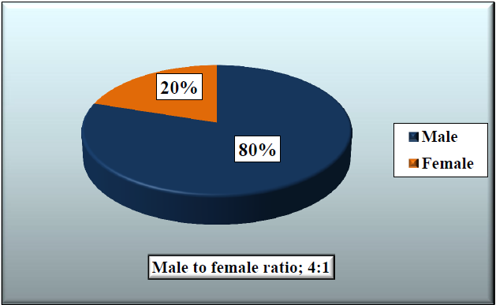
Figure 1. Gender distribution of the patients, (N=15, Male to female ratio; 4:1)
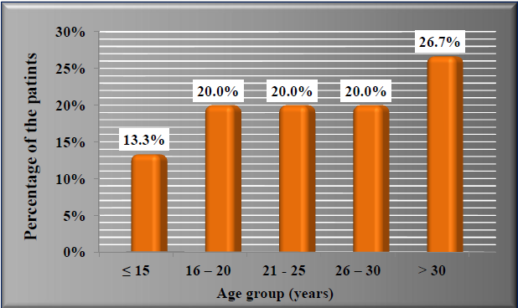
Figure 2. Age distribution as percentages of the studied group, (N=15)
Postoperative Complications
As shown in table (1) and figure(2)
As it shown in table-1 and figure- 2 fortunately, 11 patients (73.3%), had no complication, while Post-operative complication had been found in only 4 patients (26.7%) at the recipient site; two patients (13.3%) had diplopia, one patient (6.7%) had Enophthalmos and one patient (6.7%) had extrosion. Furthermore, at the donor site one patient had pain and another one had gait disturbances, which are persisting for more than one week, Pain relieved within one month after treatment with analgesia, on the other hand, gait disturbance was also relieved within one month after treatment with physiotherapy, and the patient appear normal.
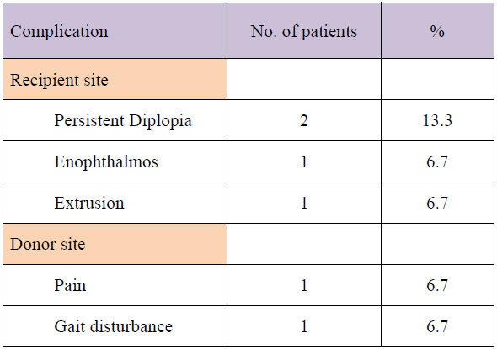
Table 1. Post-operative complications of patients.

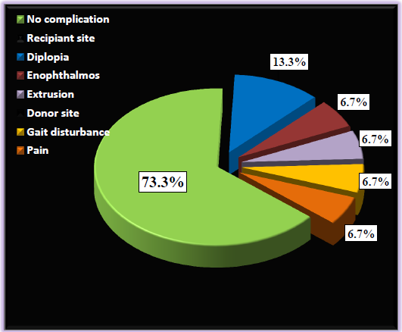
Figure 2. Proportions of post operative complications at recipient and donor sites

DISCUSSION
Patient population:
Our study yield a male to female ratio of 4:1 patient , and the highest risk group was young male. Young male population made up the highest orbital floor fracture and for trauma in general ,presumably because of the proponesity of that group to engage in a high risk activities correspond with the study of Tong et al, 2001[18]

Reconstruction material:
Various material have been used replace the damaged bone sites on maxillofacial region for reconstructive and cosmotic reasons. Fracture of the thinnest areas of orbital walls by mechanism of increased intraorbital pressure or buckling force require surgical treatment with one of these material.The goal of the operation is to restore the appropriate position of the globe inside the bony orbit [19].
There are several theories on the formation of traumatic and postoperative enophthalmos . Enlargement of bony orbit, loss of ligament support ,post traumatic fat atrophy,and scar contracture are some of the mechanisms that have been defined so far choosing the material to span the defect and determining the volume to be inserted are still difficult and contraversial step in reconstruction. Autogenous graft have been used to restore orbital anatomy for many years. Split calvarial bone which is membranous structure,is known to be advantgous in only application compared with endochondral bone, unfortunately, harvesting the cranial bone graft increase the operating time, and due to close proximity of the surgical field ,it cannot be performed simultaneously with orbital floor approach. The human cranium cannot reach its terminal thickness before the age of 17 years, for this reason dural tear, meningitis and epidural hematoma are serious and life threatening donor site complications, especially in children. various types of synthetic materials are being used successfully for orbital floor defect; however, low potential for biocompatibility and higher infection rates are still problem, despite their easy application and decreased donor site morbidity [20,21]
Autogenous iliac crest bone graft was the first material used to reconstruct the internal orbital walls and have been the gold standard to provide a framework for facial skeleton. Autogenous iliac crest ensure the establishment of bony continuity across the defect and become incorporated into the defect as a new bone, larger volume of graft material necessary for complex reconstruction are likely to be better tolerated than equal volume of alloplastic material. The other advantage is its relative resistance to infection, lack of host response, biocompatibility, osteoconductive ,osteoinductive properties, lack of concern against late extrusion/donor site morbidity, variable graft resorption , limited ability to contour are some types of disadvantages [22,23]

Extrusion:
Only one case of the (15) show a postoperatively extrusion due to that no method of fixation is applied to the piece of graft, although there are (7) cases which present with no method of fixation but there is no history of extrusion occur.

Graft failure:
No graft failure or rejection by host was seen in this group and this finding correlate with the finding of Roncevic et al [24]

Donor site complication:
Complication following iliac crest bone grafting are not infrequent the most common complication of bone harvest from the anterior iliac crest are postsurgical pain and gait disturbance and intra-operative blood loss, in a study by Forrest et al [25], pain was presented in (27%) of the cases postoperatively and require an average of (5.5) days of parentral narcotic and analgesic one case in our study which present with pain persist along one month ,the pain is moderate in severity and treated by parentral anti-inflammatory analgesic for 5 days ,then pain is subsided one case of gait disturbance are present duo to excessive muscle stripping of iliac muscle intraoperatively and persist for more than (2) weeks, the gait disturbance was recorded by assessment of limp deviation ,unsteadiness, unequalness of stride while walking 20 feet, then improved by two weeks physiotherapy[26-33].

CONCLUSIONS
- The early repair of orbital floor fracture has a better results and prognosis regarding the objective of treatment.
- Males were more affected in trauma of orbital floor.with a male to female ratio of 4:1.
- Enophthalmos was the commonest presentation followed by diplopia, echymosis, Subconjunctival hemorrrhage, Limitation of movement, Parasthesia of infraorbital nerve and epistaxis was the least frequent.
- Assult trauma, was the more frequent cause of injury followed by sport injury, fall from height and road traffic accidents respectively.Impure fracture are predomintally caused by high energy trauma while pure fractures are caused by low energy.
- Autogenous bone graft procedure is a safe operation for the repair of the orbital floor fractures with less and acceptable post operative complications reported in our study and within the reported proportions of the complications that reported in literatures and studies.
- No graft failure or rejection by host was seen in studied group.
- The appropriate material for reconstruction of orbital walls is still open for question.

RECOMMENDATION
- Further studies with larger sample size and longer duration of follow up are recommended.
- To do a comparative study between two or more standardized groups adopting early versus late treatment of orbital floor fractures and compare their outcomes.
- proper early management of traumatic orbital floor fractures with autogenous iliac bone graft will have a good outcome and reduce the adverse sequelae of these injuries.

I. Ethical approval:
The manuscript is written in original and all the data, results pertaining to this manuscript are original according to the research performed. The authors followed academic integrity and have not copied any content/results from another source.
II. Funding details (In case of Funding):
The authors of this manuscript did not receive any funding to perform the present research

III. Conflict of interest
The authors of the study do not have any conflict of interest

IV. Informed Consent:
The authors of the manuscript agrees to publish this research in the journal if it’s considerable by the editors of the journal. The authors provide full consent for reviewing and publishing this manuscript.
V. All the authors of this study contributed equally in terms of performing the research as well as in preparing the manuscript. All the authors of the study followed the guidelines of the corresponding author. Any query/suggestion related to the manuscript can be reached to the corresponding author

REFERENCES
- Chen CT, Chen YR. Application of endoscope in orbital fracture. Semin Plastic Surg 2002; 16:241–250.
- Kelley P, Crawford M, Higuera S, Hollier LH. Two hundred ninety-four consecutive facial fractures in an urban trauma center: lessons learned. Plast Reconstr Surg 2005; 116:42e–49e.
- Cruz AA, Eichenberger GC. Epidemiology and management of orbital fractures. Curr Opin Ophthalmol 2004; 15:416–421.
- Jamal BT, Pfahler SM, Lane KA, et al. Ophthalmic injuries in patients with zygomaticomaxillary complex fractures requiring surgical repair. J Oral Maxillofac Surg 2009; 67:986–989.
- Lewis, R., Tissue Engineering now coming into its own as a Scientific Field. Scientist, 1995. 9 (15): p. 12-13.
- Barr, M.L., et al., A report of the Vancouver Forum on the care of the live organ donor: lung, liver, pancreas, and intestine data and medical guidelines. Transplantation, 2006. 81(10): p. 1373-85.
- Bone_and_Joint_Decade's_Musculoskeletal_Portal.www.boneandjo intdecade. org.
- Liakovan V, Moss KF, EL – Attar A, Handley D. A comparison of imaging techniques with surgical experience in orbital injuries- a prospective study. Journal of Cranio-Maxillo-Facial Surgery 1991: 348-352.
- Siddique SA, Mathog RH. Comparison of parietal and iliac crest bone graft for orbital floor reconstruction. J Oral Maxillofac Surg 2002; 60: 44-50.
- Burm I.S, Chung CH, Oh SJ. Pure orbital blowout fracture: new concepts and importance of medial orbital blowout fracture, last Reconstr Surg 1990; 103: 183949.
- Hirota Y, Takeuchi N , Ishio K, Takasago E, kitahara N, linuma T, Blow – out fractures of the orbital – imaging modalities and therapeutic results. Nippon Jibinkoka G akkai Kaiho 1991; 94: 1123-35.
- Osguthorpe JD. Orbital Wall Fractures; evaluation and management, Otolaryngol Head Surg 1991; 105: 702-7.
- McNab AA. Orbital and optic nerve trauma. World J surg 2001; 25: 1084-8.
- Raghoebar GM, Brouwer TJ, Reintsema H, Van Oort RP: Augmentation of the maxillary sinus floor with autogenous bone for the placement of endosseous implants: a preliminary report. J Oral Maxillofac Surg 1993; 51(11): 1198-1203.
- Vriens JP, van der Glas HW, Moos KF et al. Infraorbital nerve function following treatment of orbitozygomatic complex fractures .A multi test approach. Int J Oral Maxillofac Surg 1998; 27 (1):27-32.
- Pensler J, McCarthy JG. Th e calvarial donor site: an anatomic study in cadavers. Plast Reconstr Surg 1985; 75(5):648–651.
- American_Academy_of_Orthopaedic_Surgeons, www.orthoinfo.aaos.org(accessed on May, 6, 2013).
- Tong AL, Richard B, Buchman SR, A Current 10-Year Retrospective Survey of 199 Surgically Treated Orbital Floor Fractures in a Nonurban Tertiary Care Center Plast. Reconslr. Surg. 2001; 108: 612.
- Reha Y., Serhan T., Yavuz M, et al. Reconstruction of Orbital Floor Fracture Using Solvent-Preserved Bone Graft, Plast, Reconstr. Surg. 2004;113: 34.
- Burm I.S, Chung CH, Oh SJ. Pure orbital blowout fracture: new concepts and importance of medial orbital blowout fracture, last Reconstr Surg 1990; 103: 183949.
- Waterhouse, N., Lyne, J., Urdang, M., and Garey, L. An investigation into the mechanism of orbital blowout fractures. Br. J. Oral Maxillofac. Surg. 1999; 52: 607.
- Manson, P. N., Clifford, C. M., Su, C. T., Iliff, N. T., and Morgan, R. Mechanisms of global support and posttraumatic enophthalmos: I. The anatomy of the ligament sling and its relation to intramuscular cone orbital fat. Plast. Reconstr. Sum. 1986; 77: 193.
- Manson, P. N., Grivas, A., Rosenbaum, A., Vannier, M., Zinreich, J., and Iliff, N. Studies on enophthalmos: II. The measurement of orbital injuries and their treatment by quantitative computed tomography. Plast Reconstr. Surg. 1986; 77: 203.
- Mohammed ZI, Qasim MT. Hormonal profile of men during infertility. Biochem Cell Arch 2021;21:2895–8. Available from: https://connectjournals.com/03896.2021.21.2895.
- Tahmasebi S, Qasim MT, Krivenkova MV, Zekiy AO, Thangavelu L, Aravindhan S, Izadi M, Jadidi‐Niaragh F, Ghaebi M, Aslani S, Aghebat‐Maleki L. The effects of oxygen–ozone therapy on regulatory T‐cell responses in multiple sclerosis patients. Cell biology international. 2021 Mar 16. https://doi.org/10.1002/cbin.11589
- Shabgah AG, Qasim MT, Mostafavi SM, Zekiy AO, Ezzatifar F, Ahmadi M, Haftcheshmeh SM, Navashenaq JG. CXC chemokine ligand 16: a Swiss army knife chemokine in cancer. Expert Reviews in Molecular Medicine. 2021;23. https://doi.org/10.1017/erm.2021.7
- Roncevic R, Malinger B. Experience with various procedures in the treatment of orbital floor fractures. J Maxillofac Surg. 1981;9(2):81–84.
- Forrest C, Boyd B, Manktelow R, et al. The free vascularised iliac crest tissue transfer: donor site complications associated with eighty-two cases. Br J Plast Surg. 1992 Feb-Mar;45(2):89-93.
- Dmitry Olegovich Bokov, Abduladheem Turki Jalil, Forat H. Alsultany, Mustafa Z. Mahmoud, Wanich Suksatan, Supat Chupradit, Maytham T. Qasim & Parvaneh Delir Kheirollahi Nezhad. Ir-decorated gallium nitride nanotubes as a chemical sensor for recognition of mesalamine drug: a DFT study, Molecular Simulation, 2022. DOI: 10.1080/08927022.2021.2025234
- Ansari, M.J., Jasim, S.A., Taban, T.Z. et al. Anticancer Drug-Loading Capacity of Green Synthesized Porous Magnetic Iron Nanocarrier and Cytotoxic Effects Against Human Cancer Cell Line. J Clust Sci (2022). https://doi.org/10.1007/s10876-022-02235-4
- Huldani Huldani, Saade Abdalkareem Jasim, Dmitry Olegovich Bokov, Walid Kamal Abdelbasset, Mohammed Nader Shalaby, Lakshmi Thangavelu, Ria Margiana, Maytham T. Qasim. Application of extracellular vesicles derived from mesenchymal stem cells as potential therapeutic tools in autoimmune and rheumatic diseases, International Immunopharmacology,Volume 106, 2022, 108634, ISSN 1567-5769, https://doi.org/10.1016/j.intimp.2022.108634.
- Zadeh, Firoozeh Abolhasani, et al. "Cytotoxicity evaluation of environmentally friendly synthesis Copper/Zinc bimetallic nanoparticles on MCF-7 cancer cells." Rendiconti Lincei. Scienze Fisiche e Naturali (2022): 1-7.‏
- Hafsan Hafsan,Dmitry Bokov,Walid Kamal Abdelbasset,Mustafa M. Kadhim,Wanich Suksatan,Hasan Sh. Majdi,et al . Dietary Dracocephalum kotschyi essential oil improved growth, haematology, immunity and resistance to Aeromonas hydrophila in rainbow trout (Oncorhynchus mykiss), 2022. https://doi.org/10.1111/are.15829

