*https://africanjournalofbiomedicalresearch.com/index.php/AJBR*

*Afr. J. Biomed. Res. Vol. 28(1s) (January 2025); 01-05*

*Research Article*

**"Assessment of Ala-Tragus Line Variations and Occlusal Plane Alignment in Dentulous Patients Across Age Groups: A Pilot Study"**

***\*Author of correspondence:***

*Received: Accepted:*

*DOI:*xyz

*© 2024 The Author(s).*

*This article has been published under the terms of the Creative Commons Attribution-Noncommercial 4.0 International License (CC BY-NC 4.0), which permits noncommercial unrestricted use, distribution, and reproduction in any medium, provided that the following statement is provided. “This article has been published in the African Journal of Biomedical Research”*

**Introduction:**

Fabrication of complete dentures combines biological sciences with sound mechanical principles. The ultimate goal in prosthetic dentistry is to fabricate a prosthesis that integrates seamlessly with the patient’s stomatognathic system, ensuring both function and aesthetics. In complete denture fabrication, dentists have control over multiple factors related to the prosthesis1. Although natural tooth-related issues such as mobility, caries, or malpositioning are no longer concerns, new challenges arise in ensuring that the prosthesis aligns with soft tissues for optimal functionality and aesthetic appeal1,3.

The Glossary of Prosthodontic Terms-8 defines the occlusal plane as the "average plane established by the incisal and occlusal surfaces of the teeth," which is typically not flat, but a mean curve2. Proper occlusal plane orientation is essential for aesthetics, occlusal balance, and denture function4. Incorrect positioning can lead to problems such as food accumulation, cheek or tongue biting, and denture instability, potentially causing soft tissue changes and bone resorption. A well-aligned occlusal plane supports a balanced dental occlusion5.

The occlusal plane is generally aligned anteriorly to interpupillary line for aesthetic purposes and posteriorly parallel to Camper’s plane, which extends from the lower part of the nose (acanthion) to the external auditory meatus6. The ala-tragus line has traditionally been used to establish this plane, but debate persists about which part of the tragus will be taken as reference. Additionally, the impact of aging on the position of the ala-tragus line has only recently been studied7.

In younger adults, using the inferior border of the tragus as the posterior reference resulted in a more parallel occlusal plane, while in older individuals, the middle of the tragus served as a better reference point. These findings suggest that age-related facial changes influence the optimal reference point for establishing the occlusal plane1,5.

Relocating the occlusal plane in edentulous patients presents a challenge. For occlusal rehabilitation , aligning the lost occlusal plane with the maxillary plane is more reliable than with the mandibular plane, as the former maintains a fixed orientation to craniofacial structures. The occlusal plane should be positioned as close to its original postion as possible to support normal stomatognathic function8.

Various anatomical landmarks and reference planes, including Camper’s plane and the ala-tragus line, have been proposed to guide occlusal plane relocation. Despite extensive research, no consensus has been reached on the most appropriate part of the tragus to use. Factors such as age-related anatomical changes must also be considered in complete denture construction3,9.

This study aims to evaluate the relationship between the occlusal plane, the ala-tragus line, and to determine which part of the tragus is most appropriate for orienting the occlusal plane.

**Objectives:**

- To evaluate the relationship between the occlusal plane and the palatal plane.

- To assess the relationship between the occlusal plane and Camper’s plane.

- To determine the most appropriate part of the tragus to orient the occlusal plane.

**Materials and Methods:**

The study was conducted on 90 subjects aged 18–60 years from MIDSR Dental College, Latur. with complete dentition, were selected and categorized into three age groups of 60 subjects each: Group A (18–30 years), Group B (31–45 years), and Group C (46–60 years).

The inclusion criteria for this phase of the study required patients to be indicated for dental restorative treatment. Exclusion criteria included a history of orthodontic or orthognathic treatment, absence of posterior teeth for occlusal plane determination, history of facial or temporomandibular joint surgeries, poor systemic health, bone or skin diseases, congenitally missing or extracted teeth, supraeruption or drifting of teeth, and advanced periodontal disease.

A Canon digital camera (Canon 3000D) with a specific megapixel resolution was used for computer analysis. The Fox plane was placed intraorally, contacting the incisal edges of the upper incisors and the cusps of the upper first molars bilaterally, to serve as the orientation plane for complete denture fabrication . Participants maintained this position while lateral profile photographs were taken. Subjects sat in a natural head position with their backs straight, and the camera was mounted on an adjustable tripod.

Several anatomical landmarks were marked on the photographs: the superior (a), middle (b), and inferior (c) margins of the tragus, as well as the inferior border of the ala of the nose (d). Three levels of the ala-tragus plane were analyzed:

* **ad**: Line connecting the superior margin of the tragus to the inferior border of the ala of the nose.
* **bd**: Line connecting the middle margin of the tragus to the inferior border of the ala of the nose.
* **cd**: Line connecting the inferior margin of the tragus to the inferior border of the ala of the nose.

The arms of the Fox plane, representing the occlusal plane, were compared for their parallelism to these ala-tragus lines. The images were analyzed using Microsoft PowerPoint to determine the most parallel relationship. Statistical analysis was performed using the Pearson chi-square test and the likelihood-ratio chi-square test to evaluate the data.

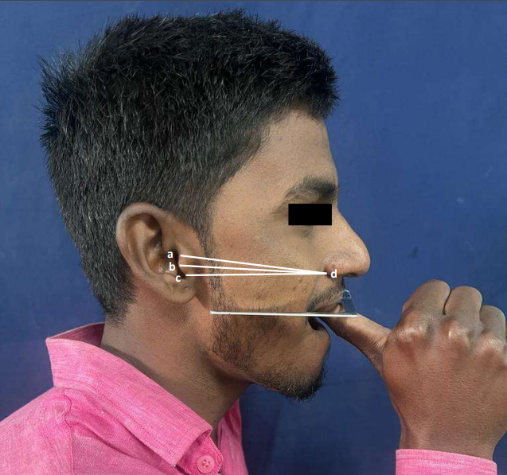

**Result-**

**Occlusal plane parallelism with the superior line:**

The occlusal plane was parallel to the superior line in 13.6% of participants in the 18–30 years age group, 34.7% in the 31–45 years age group, and 68.4% in the 46–60 years age group. This difference was statistically significant (p < 0.05).

**Occlusal plane parallelism with the middle line:**

The occlusal plane was parallel to the middle line in 22.7% of participants in the 18–30 years age group, 44.9% in the 31–45 years age group, and 26.3% in the 46–60 years age group. This difference was not statistically significant (p > 0.05).

**Occlusal plane parallelism with the inferior line:**

The occlusal plane was parallel to the inferior line in 59.1% of participants in the 18–30 years age group, 16.3% in the 31–45 years age group, and 0% in the 46–60 years age group. This difference was statistically highly significant (p < 0.001).

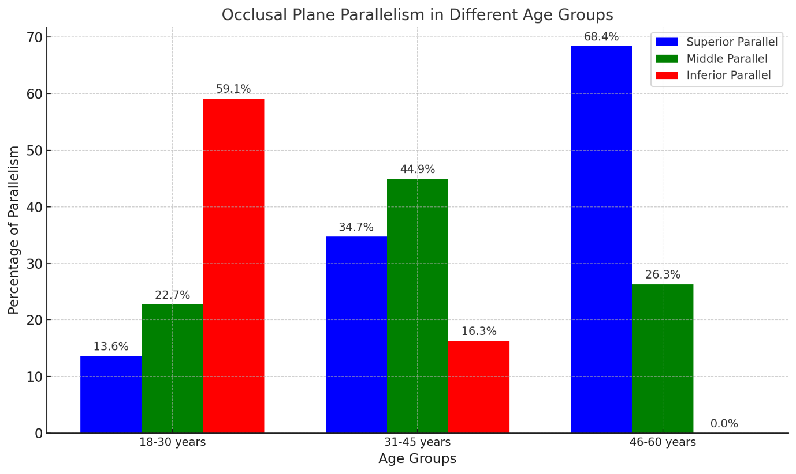

Bar graph illustrating the percentage of occlusal plane parallelism with the superior, middle, and inferior lines across different age groups.

**Discussion-**

The present study aimed to investigate the relationship between the occlusal plane and the superior, middle, and inferior borders of the tragus (forming the ala-tragus line) across different age groups. The alignment of the occlusal plane is a critical factor in prosthodontic rehabilitation, impacting both the function and aesthetics of complete dentures. Establishing the correct occlusal plane ensures optimal masticatory efficiency, phonetics, and comfort for the patient10.

Our results demonstrate a significant correlation between age and the reference point on the tragus that aligns parallel to the occlusal plane. In the youngest age group (18–30 years), 59.1% of participants exhibited occlusal planes parallel to the inferior border of the tragus, a finding that was highly significant (p < 0.001). In contrast, only 13.6% and 22.7% of this group showed parallelism with the superior and middle borders, respectively. In the middle age group (31–45 years), there was a noticeable shift. The occlusal plane was parallel to the superior border in 34.7% of participants and to the middle border in 44.9%, although the latter was not statistically significant (p > 0.05). Parallelism with the inferior border decreased markedly to 16.3%. The oldest age group (46–60 years) showed the highest parallelism with the superior border at 68.4% (p < 0.05), while none of the participants in this group had occlusal planes parallel to the inferior border

These findings align partially with previous studies but also highlight discrepancies due to the consideration of age as a variable. Traditionally, the ala-tragus line has been used to establish the occlusal plane, but there has been considerable debate over which part of the tragus serves as the most reliable posterior reference point. Some researchers advocate for the inferior border while others support the middle or superior borders .

Our study adds a new dimension by demonstrating that age significantly influences which tragal reference point aligns with the occlusal plane. This may explain the inconsistencies in previous research, as age was not uniformly considered. For instance, studies that recommended the inferior border may have had younger populations, whereas those supporting the superior border might have included older individuals.

The age-related shift in the alignment of the occlusal plane could be attributed to anatomical and physiological changes that occur with aging. As individuals age, there is a tendency for soft tissue sagging, loss of muscle tone, and changes in craniofacial morphology11 . These alterations can affect the relative positions of facial landmarks, including the tragus and the maxillary arch, thereby influencing the occlusal plane orientation12.

In younger individuals, the facial tissues are more taut, and the inferior border of the tragus may align more closely with the occlusal plane. With advancing age, the superior border becomes a more reliable reference due to changes in the auricular cartilage and surrounding tissues7,13.

The findings of this study have practical implications for prosthodontic practice. Clinicians should consider the patient's age when selecting the posterior reference point on the tragus for establishing the occlusal plane in complete denture fabrication. For younger patients, the inferior border of the tragus may serve as a more accurate guide, while for older patients, the superior border should be considered. By tailoring the reference point to the patient's age, practitioners can achieve better occlusal harmony, enhance denture stability, and improve patient comfort. This individualized approach contributes to the overall success of prosthetic rehabilitation and patient satisfaction 14.

While the study provides valuable insights, certain limitations must be acknowledged. The sample size, particularly in the oldest age group, was relatively small, which may affect the generalizability of the results. Additionally, the study population was limited to a specific geographic region, and ethnic or racial variations were not considered.

The cross-sectional design of the study captures a snapshot in time but does not account for longitudinal changes within individuals. Moreover, only dentulous and partially dentulous patients were included; fully edentulous patients might exhibit different relationships due to alveolar ridge resorption. Further studies with larger and more diverse populations are recommended to validate these findings. Longitudinal research could provide insights into how the occlusal plane and facial landmarks change within individuals over time. Additionally, incorporating advanced imaging techniques may offer more precise measurements and a better understanding of the anatomical factors influencing occlusal plane orientation. Exploring the impact of other variables, such as gender, dental status, and craniofacial morphology, could also enhance the understanding of occlusal plane determination15,16. Ultimately, developing standardized guidelines that incorporate age-related changes would benefit clinical practice and improve outcomes for patients requiring complete dentures.

**Conclusion**

The study highlights a significant relationship between age and the alignment of the occlusal plane with the ala-tragus line. Recognizing the influence of age on anatomical landmarks is crucial for accurate prosthetic rehabilitation. By adjusting the reference point on the tragus according to the patient's age, clinicians can achieve better functional and aesthetic results, leading to increased patient satisfaction and prosthesis success.

**References –**

1. Shetty S, Zargar NM, Shenoy KK, et al. Relationship Between Occlusal Plane and Three Levels of Ala-Tragus Line in Dentulous and Partially Dentulous Patients in Different Age Groups: A Pilot Study. J Clin Diagn Res. 2015;9(3):ZC58-62.
2. The Glossary of Prosthodontic Terms. J Prosthet Dent. 2005;94(1):10-92.
3. Karkazis HC, Polyzois GL. A study of the occlusal plane orientation in complete denture construction. J Oral Rehabil. 1987;14(4):399-404.
4. Younes R, El-Turk S, Bouserhal J, et al. The Ala-Tragus Line as a Guide for Orientation of the Occlusal Plane in Complete Dentures. J Prosthodont. 2014;23(6):456-60.
5. Karkazis HC, Polyzois GL. Cephalometrically predicted occlusal plane: Implications in removable prosthodontics. J Prosthet Dent. 1991;65(2):258-64.
6. Sadr K, Mahboob F, Ahmadi R. A determination of occlusal plane comparing different levels of the tragus to form ala-tragal line or Camper's line: A photographic study. J Contemp Dent Pract. 2012;13(5):618-22.
7. Gupta D, Aggarwal R, Bansal S, et al. An Analysis of Relation Among Three Levels of Ala-Tragus Line and Natural Occlusal Plane in Young Dentulous Subjects - A Cross-sectional Photographic Study. J Indian Prosthodont Soc. 2019;19(1):58-63.
8. Alam MK, Rahman SA, Basri R, et al. Relationship between occlusal plane and ala-tragus line in dentate individuals: A Clinical pilot study. J Oral Res Rev. 2015;7(1):16-20. s
9. Al Quran FA, Hazza'a AM, Rajab LD. Evaluation of the ala-tragus line as a guide for the orientation of the occlusal plane in complete dentures. J Prosthodont. 2010;19(4):231-235.
10. 10.Spratley MH. A review of the literature on current concepts of the occlusal plane. J Prosthet Dent. 1980;43(3):255-258.
11. Gupta DS, Singh SV, Bhandari AJ, et al. A cephalometric study to determine the plane of occlusion in completely edentulous patients: Part I. J Prosthodont. 2010;19(6):412-417
12. Shigli K, Chetal BR, Jabade J. Validity of soft tissue landmarks in determining the occlusal plane. J Indian Prosthodont Soc. 2005;5(3):139-145.
13. Ismail YH, Bowman JF. Position of the occlusal plane in natural and artificial teeth. J Prosthet Dent. 1968;20(5):407-411.
14. Sadr K, Sadr M. A study of parallelism of the occlusal plane and ala-tragus line using a custom-made instrument. J Prosthet Dent. 1997;77(2):152-154.
15. Solomon EG, Arunachalam KS. The occlusal plane relation to the ala-tragus line in dentate individuals: A clinical study. J Prosthet Dent. 2000;84(4):363-367.
16. Lundquist DO, Luther WW. Occlusal plane determination. J Prosthet Dent. 1970;23(5):489-498.
17. Ghosn MG, Salameh ZA, Abou-Ayash S, et al. The ala-tragus line as a guide for the orientation of the occlusal plane in complete dentures. J Prosthodont. 2014;23(1):39-42.
18. Sadr K, Sadr M. A study of parallelism of the occlusal plane and ala-tragus line using a custom-made instrument. J Prosthet Dent. 1997;77(2):152-154.
19. Boucher CO, Hickey JC, Zarb GA, Bolender CL. Prosthodontic Treatment for Edentulous Patients. 9th ed. St. Louis: CV Mosby; 1985.