Diagnostic role of Dynamic Contrast-Enhanced Magnetic Resonance Imaging in differentiating Breast Lesions.

Authors: Hussein Abed Dakhil^{1 a,b,*}, Ahmed Mohamedbaqer Easa^{2 a,b}, Ammar Yaser Hussein^{3 c}, Raad Ajeel Bustan ^{4 a,b}, Hayder Suhail Najm ^{5 a,b}.
a: Department of Technology of Radiology and Radiotherapy, Tehran University of Medical Sciences, international campus, Tehran, Iran.
b: Department of radiological, collage of health & medical technology, Al- Ayen University, Thi-Qar-IRAQ.
c: Medical Imaging Department, Al-Haboubi Teaching Hospital, Dhi Qar Health Department, Ministry of Health.
- Hussaien.abed@gmail.com
- ahmedeasa1985@gmail.com
- Ay795971@gmail.com
- Raadajeel@yahoo.com
- hayder.suhail85.hs@gmail.com
- *corresponding author - Hussaien.abed@gmail.com

Abstract:
Objective: this study aimed to assess the Diagnostic role of dynamic contrast-enhanced Perfusion weighted image (DCE-PWI) in the differentiation of benign from malignant breast lesions.
Patients and methods: The study comprised 32 women who had mammography and/or breast ultrasonography findings that were clinically questionable. All patients were fasting during the MRI test to avoid nausea or vomiting from the contrast medium.
Result: in our, study we observed the form of the dynamic curve (time and signal intensity curve) type I (persistent curve) was noted in 12 lesions (37.5%): 10 lesions were benign and 2 lesions were malignant; while type II (plateau curve) was noted in 8 lesions (25%): 3 lesions were benign and 5 lesions were malignant, and type III (washout curve) noted in 12 lesions (37.5%): 1 lesion was benign and 11 lesions were malignant.
Conclusion: the dynamic contrast-enhanced (DCE) magnetic resonance imaging perfusion technique play important role in Differentiate between benign and malignant tumours in breast cancer.
Keywords: DCE, MRI, breast cancer, differentiation, benign and malignant.
Introduction
Breast cancer is becoming a second major source of illness and death around the world. Furthermore, for researchers, the rising rate of breast cancer remains a key source of concern. Increased public awareness leads to more recurrent medical exams and diagnostic imaging, resulting in earlier diagnoses and therefore improved prognosis(1–4). MR imaging, in addition to mammography and ultrasound, is extremely useful in the detection of breast cancer due to its greater sensitivity and specificity(5–7). The use of MR Imaging in various areas of breast cancer diagnosis and therapy has been made possible by significant advancements in MRI techniques, This has allowed for precise cancer diagnosis and anatomic identification.(8–10).
The sensitivity of (DCE-MRI) in detecting breast cancer is rather high, the ranging is (88 % - 100 %) for invasive breast cancers(11,12). The observed specificity of DCE MR imaging, on the other hand, has been widely disparate, is from 37% to 97 %. The specificity of DCE MRI varies depending on the lesion criteria utilized to differentiate between benign and malignant breast lesions(5). Lesions morphology and enhancement kinetics are two widely utilized lesion criteria for identification of breast lesions by DCE MRI(13,14).
The morphological assessment of breast lesions is done by assessing their form, margins, and enhancement features, enhancement distribution, and internal enhancement pattern, according to the BIRAD MRI lexicon. The initial and post-initial enhancement of the breast lesion is detected during kinetic assessment (15–17).
The study's goal was to see how well (DCE-MRI) may separate between benign and malignant breast tumours.
Patients and methods
This prospective study was conducted in a private medical imaging centre between October 2020 and June 2021. The study included 32 women (ages 25 to 75; mean age 46.6 years) who had 32 suspicious breast lesions identified via physical examination, mammography, and ultrasonography.
All of the patients had a detailed history taken as well as a general and local examination. all patients had conventional MRI and (DCE-MRI) examinations. The findings of breast MRI were compared to the histopathology results, which were utilized as a gold standard. Patients who agreed to participate in the study gave their informed consent, and the ethics committee approved the study.
A 3-T magnetic resonance (GE) equipment was used to evaluate all of the patients. A specialized breast coil was used to exam all patients in the prone position. The examination included image acquisition followed by image post-processing.
The Protocol suggested for breast exam was:
- T2-weighted fast spin echo sequence
- T1-weighted non-fat-suppressed sequence
- DW sequence
- 3-dimensional T1-weighted fat-suppressed DCE sequence
Imaging parameters of DCE-MRI were as follows:
- repetition time= 4.1
- echo time= 2.1
- field of view= 28cm
- nex= 0.71
- matrix= 300x300
- slice thickness= 2mm
- gap= 0
The images will obtain with 6 post contrast acquisitions centered at 40, 120, 200, 280, 360, and 440s.
Result:
For their suspicious breast lesions, all 32 patients in this research got DCE-MRI, Their index lesion was also subjected to a histopathologic reference standard test. In 14 patients (43.75 percent), histopathologic examination revealed benign lesions, while in 18 individuals, malignant lesions were discovered (56.25 percent ). Types of histopathology of 14 benign lesions are listed in Table 1 As follows: 5 lesions (35.71%) were fibroadenomas, 3 lesions (21.42%) were fibrocystic changes (FCC), 2 lesions (14.28%) were mastitis, 2 lesions (14.28%) were fat necrosis, 1 lesion (7.14%) was postoperative scar, and 1 lesion (7.14%) was postoperative seroma.
Table (1): 14 benign breast lesions were histopathological diagnoses.
Histopathological type | no | %
Fibroadenoma | 5 | 35.71
Fibro cystic change | 3 | 21.42
Mastitis | 2 | 14.28
Fat necrosis | 2 | 14.28
Postoperative scar | 1 | 7.14
Postoperative seroma | 1 | 7.14
Total | 14

The histopathologic types of 18 malignant tumors are listed in Table 2: 6 lesions (33.33%) had invasive duct carcinoma, 4 lesions (22.22%) had invasive lobular carcinoma, 3 lesions (16.66%) had mucinous carcinoma, 3 lesions (16.66%) had medullary carcinoma, and 2 lesions (11.11%) had ductal carcinoma in situ (DCI).
Table (2): 18 malignant breast lesions were histopathological diagnoses.
Histopathological type | no | %
invasive duct carcinoma (IDC) | 6 | 33.33
invasive lobular carcinoma (ILC) | 4 | 22.22
mucinous carcinoma | 3 | 16.66
medullary carcinoma | 3 | 16.66
ductal carcinoma in situ (DCI) | 2 | 11.11
Total | 18

The average dimension of benign lesions was 2.7 cm, with a range of 1–7.5 cm, whereas malignant lesions were 2.9 cm, with a range of 2–6.8 cm (Table 3).
Table (3) shows a comparison of histopathological data in terms of lesion size, P: probability, Mann-Whitney U test used.
 |  | benign | malignant | p
Size (cm) | Average | 2.7 | 2.9 | 0.46
 | Range | 1–7.5 | 2–6.8

There were four rounded lesions, all of which were benign, depending on the form of the lesions. There were seven ovoid lesions in all, all of which were benign. There were ten lobulated lesions, four of which were benign and six of which were malignant, and eleven irregular lesions, four of which were benign, and seven of which were malignant. There were 8 smooth margin lesions, all of which were benign; 14 irregular margin lesions, four of which were benign and ten of which were malignant; and ten hypothesized margin lesions, three of which were benign and seven of which were malignant (Table 4).
Table (4): The morphologic features of breast lesions (in terms of form and margin) in connection to histological results, P: probability, The Mann-Whitney U test was employed.

 |  |  | Benign | Malignant | P
Shape | Rounded | No | 4 | 0 | <0.0001
 |  | % | 12.5% | 0.0%
 | Ovoid | No | 7 | 0
 |  | % | 21.87% | 0.0%
 | Lobulated | No | 4 | 6
 |  | % | 12.5% | 18.75%
 | Irregular | No | 5 | 6
 |  | % | 15.62% | 18.75%
Margin | Smooth | No | 8 | 0 | <0.0001
 |  | % | 25% | 0.0%
 | Irregular | No | 4 | 10
 |  | % | 12.5% | 31.25%
 | Speculated | No | 3 | 7
 |  | % | 9.37% | 21.87%

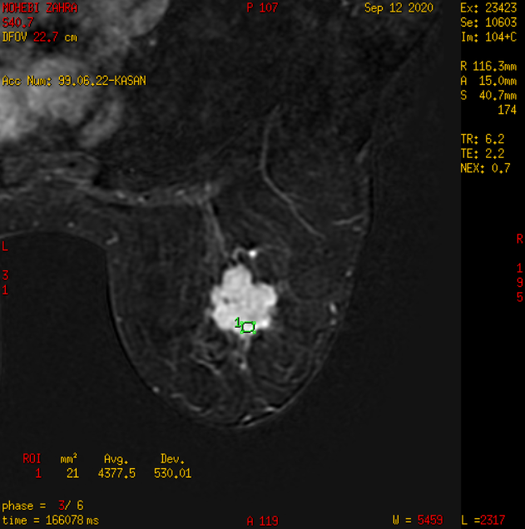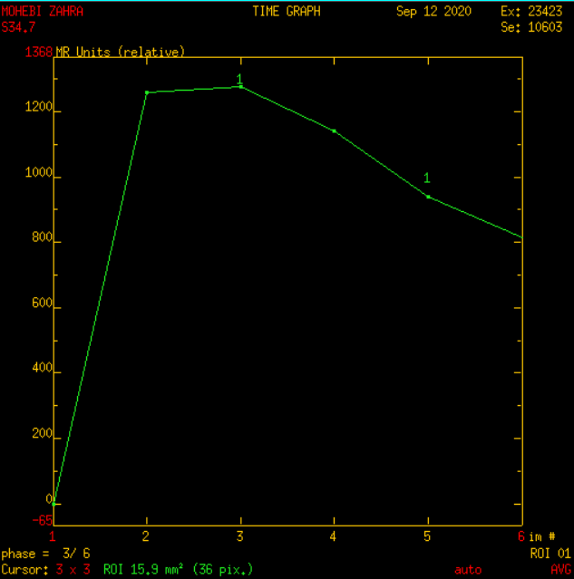
Figure 1: DCE-MRI & time/signal intensity curve: of the left breast lesion.
based on contrast enhancement pattern of the tumours homogenous enhancement was noted in 9 tumours: 6 tumours were benign and 3 tumours were malignant; heterogeneous enhancement was noted in 13 tumours: 4 lesions were benign and 9 tumours were malignant; rim enhancement was noted in 7 tumours: 3 tumours were benign and 4 tumours were malignant; and non-mass enhancement was noted in 3 tumours: 1 tumour was benign and 2 tumours were malignant. Wash-in rate was slow (50 percent) in 5 tumours, all of which were benign; moderate wash-in rate (50–80 percent) in 12 tumours, all of which were benign. 8 tumours were benign, whereas 4 were malignant; and 15 tumours had a high wash-in rate (>80%), including 1 benign lesion and 14 malignant lesions. I (persistent curve) was seen in 12 tumours based on the form of the dynamic curve (time and signal intensity curve). There were 10 benign tumours and 2 malignant tumours; type II (plateau curve) was found in 8 of the tumours: 3 tumours were benign, 5 tumours were malignant, and 12 tumours had type III (washout curve): One tumour was benign, but the other eleven were cancerous ( Table 5).
Table (5) P: probability, Mann-Whitney U test employed, This table depicts the enhancement pattern and enhancement kinetics (as regards wash in rate and shape of time/signal intensity curve) of breast lesions in relation to histopathological results.
 |  | Groups |  |  |  | P
 |  | Benign |  | Malignant
 |  | no | % | no | %
Enhancement pattern | Homogenous enhancement | 6 | 42.85 | 3 | 16.66 | <0.0001
 | Heterogeneous enhancement | 4 | 28.57 | 9 | 50
 | Rim enhancement | 3 | 21.42 | 4 | 22.22
 | Nonmass enhancement | 1 | 7.14 | 2 | 11.11
Wash in rate | Slow enhancement (<50%) | 5 | 35.71 | 0 | 0.0 | <0.0001
 | Intermediate enhancement (50–80%) | 8 | 57.14 | 4 | 22.22
 | Strong enhancement (>80%) | 1 | 7.14 | 14 | 77.77
Shape of time/SI curve | Persistent type I | 11 | 78.57 | 1 | 5.55 | <0.0001
 | Plateau type II | 2 | 14.28 | 6 | 33.33
 | Washout type III | 1 | 7.14 | 11 | 61.11

Discussion
Breast lesions may be detected with excellent accuracy using dynamic contrast-enhanced MRI. DCE-MRI has additional precision more than mammography or Ultrasonography for determining the extent of illness in patients with a recent cancer diagnosis but limited capacity to distinguish between benign and malignant lesions in individuals with a recent cancer diagnosis.
The study included 32 women (ages 25 to 75; mean age 46.6 years) who had 32 suspicious breast tumours identified via physical check-up, mammography, and ultrasonography.
32 tumours in our study divided as 14 tumours (4375%) were benign and 18 (5625%) tumours were malignant, according to Histopathologic analysis.
In this study, all mass lesions were done which revealed 32 enhanced lesions. the homogenous enhancement lesions were 9: (6 of them were benign and the other 3 lesions were malignant). The heterogeneous enhancement lesions were 13 lesions: (4 of them were benign and 9 were malignant). In rim enhancement lesions were 7: (3 lesions were benign and 4 lesions were malignant). The non-mass lesions in the present study were 3 lesions one of them was benign and the other was malignant. as shown, heterogeneous enhancement was shown to be suggestive of malignant lesions, whereas homogeneous enhancement is more likely to occur in benign lesions. While there are no particular criteria for the enhanced pattern in non-mass lesions, this supports the findings of Tozaki et al(18,19).
We observed that the tumours with smooth margin (well defined) were 8 tumours and all were benign while the tumours with irregular and speculated margin were most of them malignant This is similar to Macura et al (20,21). According to them, the margin description of a focal mass is the most predictive characteristic of breast MR image interpretation, and hypothesized margins are more worrisome for cancer The time signal intensity curve of dynamic contrast-enhanced magnetic resonance imaging In the current study revealed 12 lesions showed progressive raising curve (type I curve), by histopathology the 11 lesions were benign and 1 lesion was malignant 8 lesions showed plateau curve (type II curve), 2 lesions were benign and 6 lesions were malignant 12 lesions showed rapid washout (type III curve) 11 of them proved by histopathology as malignant This is congruent with numerous studies like Schnall et al (22,23), which demonstrated the relevance of the curve form in distinguishing between malignant and benign tumors The application of time-signal intensity curves resulted in substantially better discriminating between benign and malignant tumors Persistent curves are linked with benign lesions, but Type III curves are more suggestive for malignant Plateau curves can indicate whether a lesion is cancerous or benign (24–30).
Study limitation:
the main limitation of our study was the pandemic of coronavirus, this reason causes decreased the number of patients that participants in this study.
References:
1. Sung H, Ferlay J, Siegel RL, Laversanne M, Soerjomataram I, Jemal A, et al. Global Cancer Statistics 2020: GLOBOCAN Estimates of Incidence and Mortality Worldwide for 36 Cancers in 185 Countries. CA Cancer J Clin. 2021;71(3):209–49.
2. Berg WA, Zhang Z, Lehrer D, Jong RA, Pisano ED, Barr RG, et al. Detection of breast cancer with addition of annual screening ultrasound or a single screening MRI to mammography in women with elevated breast cancer risk. JAMA - J Am Med Assoc. 2012;307(13):1394–404.
3. Akram M, Iqbal M, Daniyal M, Khan AU. Awareness and current knowledge of breast cancer. Biol Res. 2017;50(1):1–23.
4. Labrèche F, Goldberg MS, Hashim D, Weiderpass E. Breast cancer. Occup Cancers. 2020;417–38.
5. Peters N, IH BR, NP Z, WP M, KF M, Peeters P. Meta-Analysis of MR Imaging in the Diagnosis of Breast Lesions 1 Purpose : Methods : Results : Conclusion : Radiology. 2008;246(1):116–24.
6. Menezes GLG, Knuttel FM, Stehouwer BL, Pijnappel RM, Van Den Bosch MAAJ. Magnetic resonance imaging in breast cancer: A literature review and future perspectives. World J Clin Oncol. 2014;5(2):61–70.
7. Salem DS, Kamal RM, Mansour SM, Salah LA, Wessam R. Breast imaging in the young: The role of magnetic resonance imaging in breast cancer screening, diagnosis and follow-up. J Thorac Dis. 2013;5(SUPPL.1).
8. Lee JS, Lee HY, Sung NS, Cheon KW, Moon JI, Lee SE, et al. Accuracy of physical examination, ultrasonography, and magnetic resonance imaging in predicting response to neo-adjuvant chemotherapy for breast cancer. 2016;125(11):55–9.
9. Selvi Radhakrishna, S. Agarwal1, Purvish M. Parikh2, K. Kaur3, Shikha Panwar4, Shelly Sharma5, Ashish Dey6 KKS, Madhavi Chandra5 SS. Role of magnetic resonance imaging in breast cancer management. South Asian J cancer. 2018;7(2):171–4.
10. Morrow M. Magnetic resonance imaging in the preoperative evaluation of breast cancer: Primum non nocere. J Am Coll Surg. 2004;198(2):240–1.
11. Huang W, Fisher PR, Dulaimy K, Tudorica LA, O’Hea B, Button TM. Detection of breast malignancy: Diagnostic MR protocol for improved specificity. Radiology. 2004;232(2):585–91.
12. Warren RML, Pointon L, Thompson D, Hoff R, Gilbert FJ, Padhani A, et al. Reading protocol for dynamic contrast-enhanced MR images of the breast: Sensitivity and specificity analysis. Radiology. 2005;236(3):779–88.
13. Nunes LW, Schnall M, Siegelman ES, Langlotz CP, Gorel S, Sullivan D, et al. Diagnostic performance characteristics of architectural features revealed by high spatial-resolution MR imaging of the breast. Am J Roentgenol. 1997;169(2):409–15.
14. Kuhl CK, Mielcareck P, Klaschik S, Leutner C, Wardelmann E, Gieseke J, et al. Dynamic breast MR imaging: Are signal intensity time course data useful for differential diagnosis of enhancing lesions? Radiology. 1999;211(1):101–10.
15. Kul S, Cansu A, Alhan E, Dinc H, Gunes G, Reis A. Contribution of diffusion-weighted imaging to dynamic contrast-enhanced MRI in the characterization of breast tumors. Am J Roentgenol. 2011;196(1):210–7.
16. Sohns C, Scherrer M, Staab W, Obenauer S. Value of the BI-RADS classification in MR-Mammography for diagnosis of benign and malignant breast tumors. Eur Radiol. 2011;21(12):2475–83.
17. Bi-rads ACR, Mri B. ACR Bi-Rads® Atlas — Breast MRI. Am Coll Radiol [Internet]. 2013;125–43. Available from: https://www.acr.org/-/media/ACR/Files/RADS/BI-RADS/MRI-Reporting.pdf
18. Tozaki M, Fukuda K. High-spatial-resolution MRI of non-masslike breast lesions: Interpretation model based on BI-RADS MRI descriptors. Am J Roentgenol. 2006;187(2):330–7.
19. Newell D, Nie K, Chen JH, Hsu CC, Yu HJ, Nalcioglu O, et al. Selection of diagnostic features on breast MRI to differentiate between malignant and benign lesions using computer-aided diagnosis: Differences in lesions presenting as mass and non-mass-like enhancement. Eur Radiol. 2010;20(4):771–81.
20. Macura KJ, Ouwerkerk R, Jacobs MA, Bluemke DA. Patterns of enhancement on breast MR images: Interpretation and imaging pitfalls. Radiographics. 2006;26(6):1719–34.
21. Kim YR, Kim HS, Kim HW. Are irregular hypoechoic breast masses on ultrasound always malignancies?: A pictorial essay. Korean J Radiol. 2015;16(6):1266–75.
22. Article O. The Role of Dynamic Contrast Enhanced Magnetic Resonance Imaging in Differentiation of Soft Tissue Masses. Eur J Gen Med. 2016;13(1):37–44.
23. Schnall MD, Rosten S, Englander S, Orel SG, Nunes LW. A combined architectural and kinetic interpretation model for breast MR images. Acad Radiol. 2001;8(7):591–7.
24. Li T, Yu T, Li L, Lu L, Zhuo Y, Lian J, et al. Use of Diffusion Kurtosis Imaging and Quantitative Dynamic Contrast-Enhanced MRI for the Differentiation of Breast Tumors. 2018;
25. Hetta W. Role of diffusion weighted images combined with breast MRI in improving the detection and differentiation of breast lesions. Egypt J Radiol Nucl Med [Internet]. 2015;46(1):259–70. Available from: http://dx.doi.org/10.1016/j.ejrnm.2014.10.009
26. Cuenod CA, Balvay D. Perfusion and vascular permeability : Basic concepts and measurement in DCE-CT and DCE-MRI. Diagn Interv Imaging [Internet]. 2013;94(12):1187–204. Available
27. Dmitry Olegovich Bokov, Abduladheem Turki Jalil, Forat H. Alsultany, Mustafa Z. Mahmoud, Wanich Suksatan, Supat Chupradit, Maytham T. Qasim & Parvaneh Delir Kheirollahi Nezhad. Ir-decorated gallium nitride nanotubes as a chemical sensor for recognition of mesalamine drug: a DFT study, Molecular Simulation, 2022. DOI: 10.1080/08927022.2021.2025234
28. Ansari, M.J., Jasim, S.A., Taban, T.Z. et al. Anticancer Drug-Loading Capacity of Green Synthesized Porous Magnetic Iron Nanocarrier and Cytotoxic Effects Against Human Cancer Cell Line. J Clust Sci (2022). https://doi.org/10.1007/s10876-022-02235-4
29. Huldani Huldani, Saade Abdalkareem Jasim, Dmitry Olegovich Bokov, Walid Kamal Abdelbasset, Mohammed Nader Shalaby, Lakshmi Thangavelu, Ria Margiana, Maytham T. Qasim. Application of extracellular vesicles derived from mesenchymal stem cells as potential therapeutic tools in autoimmune and rheumatic diseases, International Immunopharmacology,Volume 106, 2022, 108634, ISSN 1567-5769, https://doi.org/10.1016/j.intimp.2022.108634.

