**Journal of Population Therapeutics & Clinical Pharmacology**

**RESEARCH ARTICLE**

**DOI:** **10.53555/jptcp.v31i8.7238**

**"BLOOD GROUP CORRELATIONS IN COVID-19: EXPLORING LINKS WITH SARS-COV-2 AND RH- FACTOR"**

**Inam Ullah Khan1, Saqib Hussain2, Hazrat Ali3, Shameem Khan4, Shoaib Ali5, Wahid Ullah6, Muhammad Asif Khan7, Ahmad Ullah8, Junaid Farooq9, *Moheb Ullah Khan10**

1Department of Sarhad Institute of Allied Health Sciences (SIAHS)

Sarhad University of Science and Information Technology Peshawar KPK Pakistan

Email: inam.siahs@suit.edu.pk

2MPhil Microbiology Sarhad University of Science and Information Technology Peshawar KPK Pakistan Email: saqibhussain00616@gmail.com

3MPhil Microbiology Abasyn University Peshawar KPK Pakistan

Email: ha632721@gmail.com

4Department of Sarhad Institute of Allied Health Sciences (SIAHS)

Sarhad University of Science and Information Technology Peshawar KPK Pakistan

Email: shameemjan0@gmail.com

5Iqra National University swat campus KPK Pakistan

Email: ashoaib0313@gmail.com

6Department of Sarhad Institute of Allied Health Sciences (SIAHS)

Sarhad University of Science and Information Technology Peshawar KPK Pakistan

Email: khanwahid038@gmail.com

7Department of Pharmacy Sarhad University of Science and Information Technology Peshawar

KPK Pakistan Email: asif.fls@suit.edu.pk

8*Department of Biotechnology University of Science and Technology Bannu KPK Pakistan

Email: ahmadreena5598@gmail.com

9Institute of Biotechnology and Microbiology Bacha Khan University Charsadda KPK Pakistan Email: junaid.farooq2009@gmail.com

**\*Corresponding Author:** Mr. Moheb Ullah Khan PhD Scholar

**+** Department of Biotechnology University of Science and Technology Bannu KPK Pakistan

Email: [mohibk807@gmail.com](mailto:mohibk807@gmail.com)

**Abstract**

This study aimed to investigate the potential correlation between COVID-19 and blood groups, focusing on the ABO blood typing system and the Rh factor. With specific objectives in mind, the research delved into discerning any potential links between different blood group types and the impact on the severity of COVID-19 symptoms. Employing a systematic methodology, a diverse cohort was analyzed to identify potential associations or predispositions linked to specific blood groups concerning COVID-19 transmission and disease severity. The study's outcomes offer insights into the potential relevance of blood group types in understanding the dynamics of COVID-19, potentially contributing to tailored preventive strategies and personalized clinical approaches for managing the disease.

**Introduction:**

The emergence of the Coronavirus Disease 2019 (COVID-19) pandemic has become a paramount concern on a global scale. Caused by the Severe Acute Respiratory Syndrome Coronavirus 2 (SARS-CoV-2), this disease has spurred extensive efforts in vaccine development, although adherence to Standard Operating Procedures (SOPs) such as maintaining social distance remains crucial. Originating in December 2019, the outbreak was initially linked to a cluster of pneumonia cases with an unidentified source at a seafood market in Wuhan, China (Harapan *et al*., 2020).

Despite stringent containment measures, COVID-19 rapidly disseminated within Wuhan and subsequently throughout China, straining healthcare systems and resources. Its relentless person-to-person transmission swiftly escalated into a global emergency, prompting intensive research into identifying risk factors associated with susceptibility and disease severity. Multiple population-based studies have unveiled diverse factors correlating with exacerbated outcomes post-COVID-19 contraction, encompassing demographics, pre-existing medical conditions, and notably, blood type associations (Kim *et al*., 2021).

Investigations into blood type as a potential risk factor for COVID-19 have gained traction owing to previous associations found in various diseases. Prior studies linked ABO polymorphism to susceptibility and even protection against SARS-CoV-1 infection, unveiling possible molecular mechanisms influencing infection and transmission (Richardson *et al*., 2020; Hoiland *et al*., 2020; Barnkob *et al*., 2020). These findings spurred inquiries into a potential correlation between SARS-CoV-2 and blood antigen groupingLarge-scale studies from diverse populations worldwide have examined the relationship between blood type and COVID-19, revealing varying associations between specific blood types and susceptibility to infection. This cross-sectional study conducted in Peshawar investigated 130 confirmed COVID-19 cases, aiming to explore the association between ABO and Rh blood grouping and the incidence of COVID-19 (Barnkob*et al*., 2020).

Understanding the potential relationship between blood type and COVID-19 susceptibility could significantly impact risk stratification and prognosis, aiding in more targeted preventive strategies and personalized patient management approaches. This study aims to contribute valuable insights to this evolving area of research, shedding light on the role of blood group types in the context of COVID-19 infection and its implications for public health.

**Methodology**

## StudyDesign

This retrospective, single-center study was conducted at Hayatabad Medical Complex (HMC) in Peshawar. The study received approval from the Medical Superintendent (MS) of the hospital. The primary objective was to investigate the potential association between ABO and Rh blood groups and their impact on various facets of coronavirus disease 2019 (COVID-19) infection, including susceptibility, disease severity, length of hospital stay, and patient mortality. The study's analysis centered on the ABO blood group and Rh blood group systems.

**Study location and period**

The study was conducted at the Medical Laboratory Technology Laboratory, SIAHS, SUIT, Peshawar, Khyber Pakhtunkhwa, during a specified period in 2022. Blood samples were obtained from the Corona ward of Hayatabad Medical Complex (HMC) Peshawar, utilizing sterile syringes and EDTA tubes.

**Selection criteria for case**

This study encompassed a total of 130 patients diagnosed with confirmed COVID-19 positivity, determined through real-time PCR for coronavirus disease 2019. These individuals comprised the case group for this investigation. All patients included in this study were admitted to Hayatabad Medical Complex (HMC) Peshawar between April 8, 2020, and October 4, 2020.

**Sample collection**

A total of 130 blood samples were collected from patients confirmed positive for COVID-19 via RT-PCR testing at Hayatabad Medical Complex (HMC) in Peshawar. The collection process adhered to stringent aseptic techniques using sterile disposable syringes and sterile EDTA tubes.

**Sample processing**

Upon collection, the blood samples were transferred onto glass slides in three separate drops. Each drop was then individually mixed with specific anti-sera:

1. **First Drop:** Mixed with anti-sera A.
2. **Second Drop:** Mixed with anti-sera B.
3. **Third Drop:** Mixed with anti-D.

**Interpretation**

Each blood sample was mixed separately with antibodies directed against antigens A, B, and D. The samples were then observed to ascertain whether agglutination (clumping) occurred when the blood cells interacted with the specific antibodies. Based on the observed reactions, the results were meticulously noted down according to predefined criteria outlined in Table 3.1 and Table 3.2.

**Different blood groups with RH factors**

The determination of blood group types and Rh factor followed specific observations based on agglutination reactions with different antisera.

**Blood Group A:** Agglutination observed with antisera A indicated blood group "A".

**Blood Group B:** Agglutination observed with antisera B indicated blood group "B".

**Blood Group AB:** Agglutination observed with both anti-A and anti-B indicated blood group "AB".

**Blood Group O:** No agglutination observed with anti-A and anti-B indicated blood group "O".

**Rh Positive Blood Group:** Agglutination observed with anti-Rh D indicated a positive Rh factor.

**Rh Negative Blood Group:** No agglutination observed with anti-Rh D indicated a negative Rh factor.

**Table3.1:Evaluationof ABObloodgroupsbyantisera**

|  |  |  |
| --- | --- | --- |
| **Anti-A** | **Anti-B** | **Bloodgroup** |
| +ve | -ve | A |
| -ve | +ve | B |
| +ve | +ve | AB |
| -ve | -ve | O |

**Table 3.2:Evaluation of Rh blood groupbyanti-D**

|  |  |
| --- | --- |
| **Anti-D** | **Bloodgroup** |
| +ve | Dpositive |
| -ve | Dnegative |

Agglutination=+ ve Noagglutination=-ve

# RESULTS

## StudysitesandSampleCollection:

## The current study aimed to investigate the susceptibility of individuals based on ABO and Rh blood groups concerning COVID-19. A total of 130 blood samples were collected from patients confirmed positive for COVID-19 via RT-PCR, admitted to the Corona Ward of Khyber Teaching Hospital, Peshawar. Demographic details such as name, gender, specific ward information, and concurrent medical conditions were meticulously recorded for each participant.

**Table 4.1.Overall ratio of male to female**

|  |  |  |  |
| --- | --- | --- | --- |
| **Totalpatient** | **Male** | **Female** | **Ratio** |
| **130** | **96 (73.8%)** | **34 (26.2%)** | **48:17** |

## Overall ratio of male and female patients

## The study comprised 130 patients, with males accounting for the majority, constituting 96 individuals (73.8%), while females represented 34 individuals (26.2%). The male-to-female ratio was recorded as 48:17, as presented in Table 3 and illustrated in Figure 4.1. The age range of the patients spanned from 10 years to 70 years, as detailed in Table 4.2.

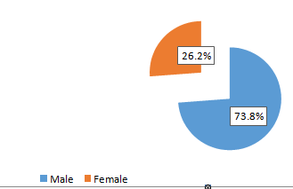

**Fig.4.1.Diagrammaticrepresentationofoverallmaletofemaleratio4.3AgeandsexdistributionofCOVID-19 Positive Patient**

**Table4.2.AgedistributioninCOVID-19Positivepatient**

|  |  |
| --- | --- |
| Ageofpatientin year | Number of patient |
| 10 to30 | 5 (3.8%) |
| 31 to50 | 36(28.5%) |
| 51 to70 | 88(68.7%) |
| **Totalnumber** | 130 (100%) |

**Age and sex distribution of COVID-19 positive patients**

Among the 130 COVID-19 positive patients sampled, varying infection rates were observed across different age groups. The highest infection rate was notably observed in individuals aged 51-70 years, accounting for 68.7% of the cases. In the age bracket of 31-50 years, the infection rate stood at 28.5%, while individuals aged 10-30 years exhibited the lowest infection rate, representing only 3.8% of the cases. These findings are detailed in Table 4.3.

**Table.4.3.Age andsex distributionofCOVID-19 positivepatients**

|  |  |  |  |
| --- | --- | --- | --- |
| **AgeofPatientin year** | **Female34(26.2%)** | **Male96 (73.8%)** | **Totalnumber (130)** |
| **10-30** | **1(0.7%)** | **4(3.0%)** | **5 (3.8%)** |
| **31-50** | **10(7.6%)** | **27(20.7%)** | **36(28.5%)** |
| **51-70** | **23(17.6%)** | **65(50.0%)** | **88(68.7%)** |

## Ageandblood groupdistributionof COVID-19positivepatient

Certainly, here's a summarized breakdown of the blood group distribution among COVID-19 positive patients based on age groups:

**Table.4.4.Ageof PatientandBloodgroupofPatientCrosstabulation**

|  |  |  |  |  |  |  |  |  |  |
| --- | --- | --- | --- | --- | --- | --- | --- | --- | --- |
| **Age of Patient** | **Bloodgroupof Patient** | | | | | | | | **Total** |
| **A -ve** | **A +ve** | **B –ve** | **B +ve** | **AB -ve** | **AB +ve** | **O -ve** | **O +ve** |
| **10-30 Years** | **1** | **3** | **0** | **1** | **0** | **0** | **0** | **0** | **5** |
| **31-50 Years** | **4** | **18** | **1** | **6** | **2** | **2** | **1** | **4** | **37** |
| **51-70 Years** | **4** | **20** | **7** | **25** | **2** | **10** | **1** | **18** | **89** |
| **Total** | **9** | **41** | **8** | **32** | **4** | **12** | **2** | **22** | **130** |

Table 4.4 represents the blood group distribution among COVID-19 positive patients in each specified age.

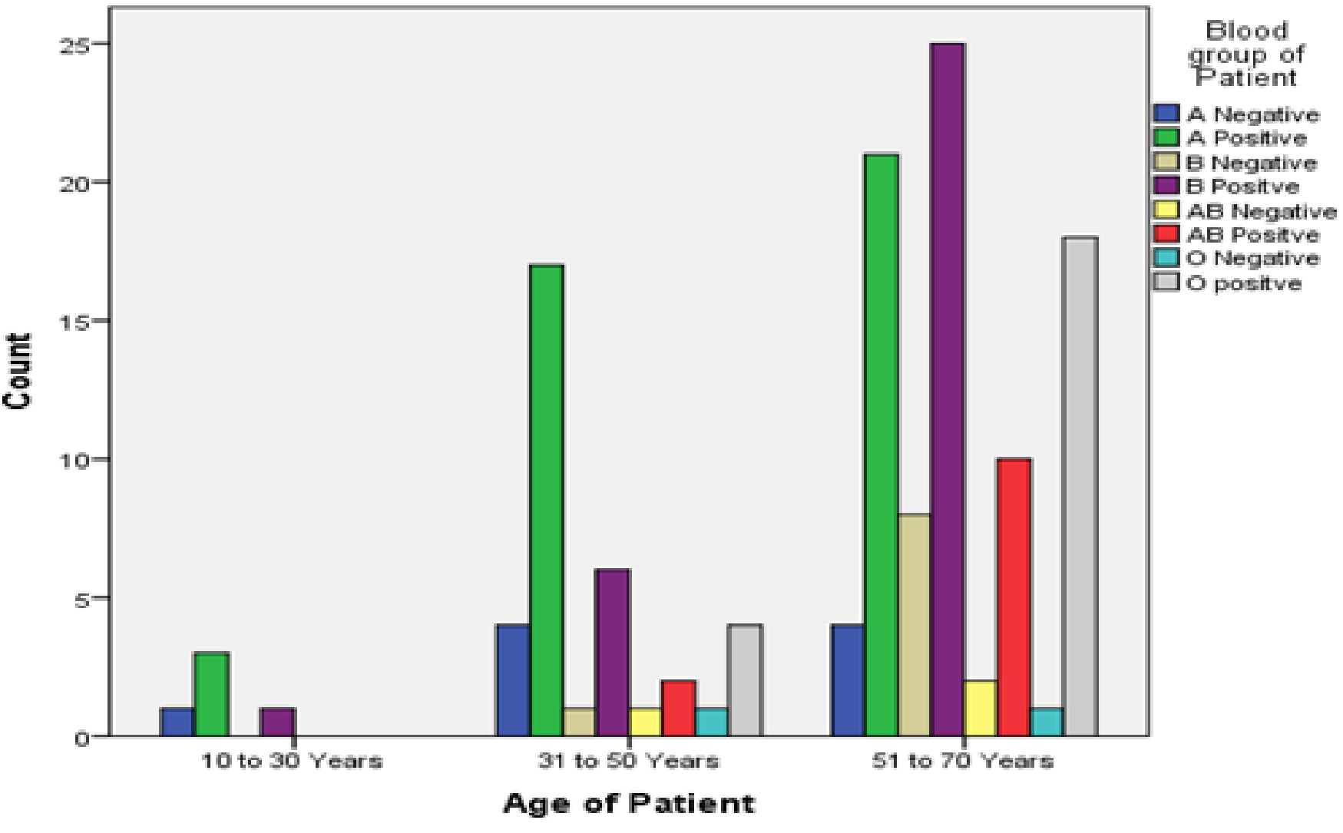

**Fig.4.2. Diagrammatic representation of Age of Patient and Blood group of Patient Crosstabulation**

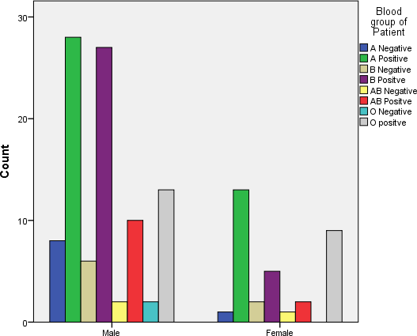

**Fig.4.3.Diagrammaticrepresentationof distributionofbloodgroupinmaleandfemale.**

**Overall distributionblood group“A”COVID-19patient**

Certainly, here's a condensed summary of the blood group distribution among 130 patients:

**Table.4.5.Overalldistributionofblood group“A positive”and“ANegative**

|  |  |  |
| --- | --- | --- |
| **Total** | **Apositive** | **ANegative** |
| **50 (38.4%)** | **41 (31.5%)** | **9(7.0%)** |

This data indicates that among the 130 patients, the highest number, comprising 38.4% of the total, belonged to blood group "A". Within this group, 31.5% were A Positive, and 7.0% were A Negative.

**Overalldistributionbloodgroup“B”inCOVID-19patient**

Certainly, here's a brief summary of the blood group distribution among the 130 patients:

**Table.4.6.Overalldistributionofbloodgroup“Bpositive”and“BNegative”**

|  |  |  |
| --- | --- | --- |
| **Total** | **Bpositive** | **BNegative** |
| **40 (30.8%)** | **32 (24.6%)** | **8(7.0%)** |

Among the 130 patients, the second-highest number, accounting for 30.8% of the total, belonged to blood group "B". Within this group, 24.6% were B Positive, and 6.2% were B Negative.

**Overalldistributionblood group“AB”inCOVID-19patient**

Certainly, here's a summarized breakdown of the blood group "AB" distribution among the 130 patients:

**Table.4.7.Overalldistributionofbloodgroup“ABpositive”and“ABNegative”**

|  |  |  |
| --- | --- | --- |
| **Total** | **ABpositive** | **ABNegative** |
| **16 (12.3%)** | **12 (9.2%)** | **4(2.3%)** |

Among the 130 patients, the blood group "AB" was the least common, comprising 12.3% of the total. Within this group, 9.2% were AB Positive, and 3.1% were AB Negative.

**Overall distributionblood group“O”inCOVID-19patient**

Certainly, here's a brief summary of the blood group "O" distribution among the 130 patients:

**Table.4.8.Overalldistributionofbloodgroup“Opositive”and“O Negative”**

|  |  |  |
| --- | --- | --- |
| **Total** | **O positive** | **ONegative** |
| **14 (18.4%)** | **22 (16.9%)** | **2 (1.5%)** |

Among the 130 patients, the blood group "O" comprised 24 individuals. Within this group, 22 were O Positive, and 2 were O Negative.

**Overall distributionRhbloodgroupin COVID-19patient**

Certainly, here's a concise summary of the susceptibility to COVID-19 based on Rh factor:

## Table.4.9.Overalldistributionof Rh positiveand Rhnegativeblood group.

|  |  |  |
| --- | --- | --- |
| **Total** | **Rh positive** | **ONegative** |
| **130 (100%)** | **107 (82.3%)** | **23 (17.7%)** |



35

31

30

25

25

20

17

15

10

9

7

7

5

2

2

0

A APositive B BPositive Ab AB O OPositive

Negative Negative Negative Positive Negative

Series1

**Fig.4.4.Frequencyof BloodgroupsinCovid-19Patients**

According to your study among the 130 patients, 82.3% were Rh Positive, while 17.7% were Rh Negative. This suggests a higher prevalence or susceptibility to COVID-19 among individuals with Rh Positive blood groups compared to those with Rh Negative blood groups.

**Table.4.10.FrequencyofBloodgroups inCovid-19 Patients**

|  |  |  |  |  |  |
| --- | --- | --- | --- | --- | --- |
| **BloodgroupofPatient** | | | | | |
|  | | **Frequency** | **Percent** | **ValidPercent** | **CumulativePercent** |
| Valid | ANegative | 9 | 7.0 | 7.0 | 6.9 |
| APositive | 41 | 31.5 | 31.5 | 38.5 |
| BNegative | 9 | 7.0 | 7.0 | 45.4 |
| BPositive | 32 | 24.6 | 24.6 | 70.0 |
| ABNegative | 3 | 2.3 | 2.3 | 72.3 |
| ABPositive | 12 | 9.2 | 9.2 | 81.5 |
| ONegative | 2 | 1.5 | 1.5 | 83.1 |
| OPositive | 22 | 16.9 | 16.9 | 100.0 |
| **Total** | **130** | **100.0** | **100.0** |  |

**DISCUSSION**

The COVID-19 pandemic has caused a significant global health crisis due to its rapid and easy transmission through respiratory droplets, close contact, airborne transmission, and contact with contaminated surfaces. Symptoms typically appear after an incubation period of 2–14 days post-exposure. This study aimed to assess the prevalence and susceptibility of ABO and Rh blood groups among COVID-19 patients in the Peshawar region, with a sample size of 130 individuals.

Among the participants, 73.8% were male, while 26.2% were female, aligning with similar gender prevalence reported in other studies (Noreen *et al*., 2020; Raimondi *et al*., 2021). Blood group A was the most prevalent at 38.4%, followed by B at 30.8%, O at 18.4%, and the least common was AB at 12.3%. These findings are in agreement with a study conducted in NUMS Rawalpindi, displaying similar prevalence rates among different blood groups (37.4% for A, 32.8% for B, 21.8% for O, and 8% for AB).

The study revealed a higher frequency of COVID-19 in the Rh Positive blood group (82.3%) compared to Rh Negative (17.7%), consistent with findings from other studies such as one conducted in a hospital in Turkey (Arac*et al*., 2020) reporting 88.4% Rh Positive and 11.6% Rh Negative.

Age was found to significantly impact COVID-19 prevalence, with the highest number of samples collected from the age group 51-70 years (68.5%), followed by 31-50 years (27.7%), and 10-30 years (3.8%). Similar age-related findings were observed in other studies (Hendren *et al*., 2021).

Recent research has aimed to identify patient-specific risk factors for SARS-CoV-2 infection. ABO blood type and Rhesus status have been explored as potential markers influencing susceptibility to COVID-19. This study provides valuable insights into these factors, particularly within the Pashtun population of Khyber Pakhtunkhwa province in Pakistan. However, it's crucial to acknowledge that this study represents a single-center experience and might not fully represent the entire Pakistani population (Asghar*et al*., 2020).

## Conclusions

In conclusion, our study underscores a significant correlation between ABO blood types and COVID-19 vulnerability. We observed heightened susceptibility to COVID-19 infection among blood groups A, B, and Rh positive individuals compared to blood groups O, AB, and Rh negative, which demonstrated substantially lower risk of contracting COVID-19. Specifically, within A and B blood groups, blood type A exhibited a greater susceptibility than blood type B. Clinicians should exercise heightened vigilance when treating SARS-CoV-2 infected patients with blood type A, considering their elevated mortality rates, necessitating comprehensive investigations and aggressive management.

Conversely, blood type AB seemed to offer some level of protection against COVID-19 infection, displaying a lower likelihood of testing positive compared to non-AB blood types. The discrepancies observed might be attributed to variations in ethnicities and genetic backgrounds among the study populations. Therefore, further investigations on a larger scale are imperative to gain a more comprehensive understanding of the association between ABO/Rh-D blood types and susceptibility to COVID-19.

We advocate for larger, multicenter, and prospective studies to validate and better elucidate the relationship between blood groups and susceptibility to SARS-CoV-2. Such comprehensive studies are essential for developing more targeted preventive strategies and enhancing clinical management approaches for COVID-19 patients based on their blood group profiles.

**REFERENCES**

1. Arac,E.(2020).AssociationBetweentheRhBloodGroupandtheCovid-19Susceptibility.*InternationalJournalofHematologyandOncology,30*(2),81-86.
2. Asghar,M.S.,Kazmi,S.J.H.,Khan,N.A.,Akram,M.,Hassan,M.,Rasheed,U.,&Khan,S. A. (2020). Poor prognostic biochemical markers predicting fatalities caused byCOVID-19:aretrospectiveobservationalstudyfromadevelopingcountry.*Cureus,12*(8).
3. Barnkob,M.B.,Pottegård,A.,Støvring,H.,Haunstrup,T.M.,Homburg,K.,Larsen,R.,Barington,T.(2020).ReducedprevalenceofSARS-CoV-2infectioninABObloodgroupO. *Blood Advances, 4*(20), 4990-4993.
4. Harapan,H.,Itoh,N.,Yufika,A.,Winardi,W.,Keam,S.,Te,H.,Mudatsir,M.(2020).Coronavirus disease 2019 (COVID-19): A literature review. *Journal of InfectionandPublicHealth, 13*(5), 667-673.
5. Hendren, N. S., De Lemos, J. A., Ayers, C., Das, S. R., Rao, A., Carter, S., Khera, R.(2021). Association of body mass index and age with morbidity and mortality inpatientshospitalizedwithCOVID-19:resultsfromtheAmericanHeartAssociationCOVID-19CardiovascularDiseaseRegistry.*Circulation,143*(2), 135-144.
6. Hoiland,R.L.,Fergusson,N.A.,Mitra,A.R.,Griesdale,D.E.,Devine,D.V.,Stukas,S.,Chen,L.Y.(2020).TheassociationofABObloodgroupwithindicesofdiseaseseverity and multiorgan dysfunction in COVID-19. *Blood Advances, 4*(20), 4981-4989.
7. Kim,Y.,Latz,C.A.,DeCarlo,C.S.,Lee,S.,Png,C.Y.M.,Kibrik,P.,Dua,A.(2021).RelationshipbetweenbloodtypeandoutcomesfollowingCOVID-19infection.*SeminarsinVascular Surgery,34*(3),125-131.
8. Noreen, N., Naveed, I., Dil, S., Niazi, S., Saleem, S., Mohiuddin, N., Khan, F. (2020).TrendAnalysisofexponentialincreaseofCovid-19casesinPakistan:Aninterpretation. *Global Biosecurity, 2*(1)231-263.
9. Raimondi,F.,Novelli,L.,Ghirardi,A.,Russo,F.M.,Pellegrini,D.,Biza,R.,Group,H.P.G.C.-S.(2021).Covid-19andgender:lowerratebutsamemortalityofseveredisease in women—an observational study. *BMC Pulmonary Medicine, 21*(1), 96-111.
10. Richardson,S.,Hirsch,J.S.,Narasimhan,M.,Crawford,J.M.,McGinn,T.,Davidson,K.W.,&Consortium,a.t.N.C.-R.(2020).PresentingCharacteristics,Comorbidities,and Outcomes Among 5700 Patients Hospitalized With COVID-19 in the NewYorkCityArea.*JAMA, 323*(20), 2052-2059.