
Journal of Population Therapeutics & Clinical Pharmacology
RESEARCH ARTICLE
DOI:
Aldose reductase inhibitory potential of Patuletin: a comprehensive in vitro analysis integrating ADMET, molecular docking, and MD studies for predicted upstream anticancer pathway

Mahwish Fatima^{1,2}, Syeda Afroz², Arooj shafiq¹, Abdul Hameed³, Paras Jawaid¹, Jawad Zahid², Syeda Izma Hashmi⁴, Aisha Hasan², Mati Ur Rehman¹*

¹Department of Biological and Biomedical sciences, Aga Khan University Karachi, Pakistan.
²Department of Pharmacology, Faculty of Pharmacy and Pharmaceutical Sciences, University of Karachi, Pakistan.
³Department of Molecular Medicine, Ziauddin University, karachi, Pakistan.
⁴Department of Physical Therapy, University of Karachi, Pakistan.
*Corresponding author: Dr. Mati Ur Rehman,
Assistant Professor, Department of Biological and Biomedical Sciences, The Aga Khan University, National Stadium Road, Karachi-74800, Pakistan, Email: mati.rehman@aku.edu

Abstract:
Patuletin is a rare flavonoid with various anticancer, anti-inflammatory, antiviral, antinociceptive, and skin-lightening effects. It inhibits fatty acid synthase, lipoxygenase, TNF alpha, and targets the JAK-STAT system, reducing ROS through p38 and NF-κB. Patuletin triggers PARP and caspase 3 activation, which are linked to the enzyme aldose reductase.
This study evaluates the predicted inhibitory pathway of patuletin as an aldose reductase inhibitor using SWISSADME, PKSCM web tools, Stoptox, protox 3.0, Swiss target prediction, passonline, similarity ensemble approach (SEA), IMOD platform, Swiss Autodock Vina, Pyrx, and Discovery Studio for molecular docking.
Patuletin has a logP (lipophilicity) of 2.0 and TPSA of 140.9Å², which may limit bioavailability and cause drug interactions. It is non-toxic for acute inhalation and oral toxicity but exhibits toxic behavior for acute dermal toxicity. Swiss Target Prediction predicts its most probable protein targets, including 27.6% of lyases, 20% of enzymes, 13.3% of kinases, and 6.7% of proteases, oxidoreductases, and family A G couple protein receptors. The Similarity Ensemble Approach (SEA) evaluates ligand similarity using the Tanimoto coefficient (Tc). Patuletin showed the highest TC with Aldo-keto reductase family 1 member B1 (AKR1B1) 0.86 for rat and 0.7 for human. The study investigates the molecular docking of the aldose reductase protein with the ligand nicotinamide adenine dinucleotide phosphate (NADP) and the standard drug epalrestat. The results show that patuletin is more effective than regular epalrestat due to its inhibitory properties and binding affinity. The molecular docking tests for patuletin against 1ADS and against epalrestat showed similar binding energy. All three ligands showed the same site interactions i.e. Trp20, Tyr209 Tyr48, ASN160 and Cys298 and a Swissdock was used for molecular revalidation, confirming the same results.
It is concluded that patuletin may target aldose reductase AKR1B1 and have an inhibitory effect; however, additional experimental testing is necessary to confirm this possibility.

Key words: Patuletin, aldose reductase, molecular docking, ADMET, anticancer

Introduction:
Historically, medicinal plants have served as a primary source for drug development, with 80% of initial pharmacological agents derived from herbal sources. Flavonoids, a class of plant-derived polyphenols, exhibit anticancer properties by suppressing cancer cell development, inducing cancer cell death, and limiting tumor progression through various molecular mechanisms. [1]
One of the main flavonoids in Tagetes patula is patuletin, identified in 1941 as a non-toxic member of the flavonols class.[2]. Easily extracted from flowers, patuletin has demonstrated various therapeutic effects in preclinical research, including anti-inflammatory, anticancer, antiviral, antinociceptive, and skin-lightening properties. It specifically targets the fatty acid synthase gene in human breast cancer cells, leading to apoptosis, with active caspase-3 and PARP being key mediators in this process. The compound is essential for chromatin condensation, DNA fragmentation, and apoptotic body formation, linking its activity through the polyol pathway. [3].
The metabolism of cancer cells is altered to support rapid growth and survival, with the polyol pathway playing a key role in connecting glucose metabolism to cancer aggressiveness and treatment resistance. This pathway involves two main enzymes: aldose reductase (AKR1B1) and sorbitol dehydrogenase, which convert glucose to sorbitol and then to fructose. AKR1B1 employs NADH or NADPH to oxidoreduce various substances and serves as a defense mechanism against toxic aldehydes produced during oxidative stress, including byproducts like glutathionyl-4-hydroxy-2-nonenal and acrolein, as well as lipid peroxidation products such as 4-hydroxy-2-nonenal and methylglyoxal.[4]

Aldose reductase enzymes have a role in chemoresistance, as they break down carbonyl-containing medications like naloxone and ketotifen. The anthracycline antibiotics i.e. doxorubicin and daunorubicin are significant cases, but their efficacy is diminished when their carbonyl group is reduced to its equivalent alcohol. These drugs become ineffective when AKR1B1 is overexpressed, and inhibiting AKR1B1 can increase the cytotoxic effects of cisplatin and doxorubicin in HeLa cervical cancer cells [5]. Also JAK2 and STAT5 are subsequently activated when the aldose reductase pathway is activated, according to experimental research conducted in ischemic rat hearts. JAK2/STAT5 activation is blocked by inhibiting aldose reductase or similar enzymes, indicating a direct upstream action.[6] AKR1B1 inhibition decreases NF-κB-dependent inflammatory indicators, TNF-α production triggered by hyperglycemia, and inflammatory mediators such as NO and PGE.[7] There are 15 distinct AKRs in humans essential for the metabolism of lipid and sugar aldehydes, such as end products of advanced glycation, chemical carcinogens, and 4-hydroxy-2-nonenal (4-HNE)[8]. AKR1B10 has cytoprotective function in lung, colon, brain cells, and the small intestine . AKR1B1 is also linked to treatment resistance in medulloblastoma. The SH-SY5Y neuroblastoma cell line expresses AKR1B1, which contributes to the cytoprotective detoxification of reactive aldehydes including 4-hydroxy-2-nonenal (HNE).[9] The Nrf2 pathway can affect this enzyme's expression, which can be up-regulated by some treatments like F-α-PNP, resulting in less cell damage.[10] Aldose reductase activity serves as a stress-reduction mechanism, and researchers are creating AKR1B1 inhibitors to improve cell sensitivity to treatments or lessen damage from diseases like persistent oxidative stress.[11]
Aldose reductase (AR) inhibition reduces pro-inflammatory mediator synthesis by regulating the arachidonic acid (AA) metabolic pathway, which inhibits lipoxygenase (LOX) activity. It prevents the activation of enzymes such as 5-lipoxygenase (5-LOX) and cyclooxygenase-2 (COX-2), implicating AR in inflammation initiation. The study highlights that chemicals from Pistacia integerrima, particularly spinacetin and patuletin, exhibit strong lipoxygenase inhibitory activity [12]. Fidarestat, an AR inhibitor with completed Phase-III clinical trials approved by the FDA, has shown no harmful side effects and may be utilized in various cancer treatments. Further trials combining AR inhibitors or siRNAs with established chemotherapeutic agents are necessary to assess clinical toxicity.[13]. Epalrestat inhibits aldose reductase enzymes AKR1B1 and AKR1B10, which are involved in metabolic control and cell proliferation, and their inhibition could impede tumor growth.[14]
Method:
Evaluation of Pharmacological Properties:
Absorption, Distribution, Metabolism, Excretion, and Toxicity Analysis (ADMET Analysis)
Swiss ADME: Researchers can assess the drug-likeness and ADME properties of small compounds using the free web application SwissADME, which is especially useful early in drug development to determine a chemical's viability as an oral medication. The ADME analysis involves several steps, starting with the preparation of molecular structures in formats like SDF or SMILES, and selecting relevant compounds. Tools such as SwissADME predict the penetration of the blood-brain barrier (BBB) and gastrointestinal absorption (GI), as well as interactions with P-glycoprotein and the CYP450 enzyme. Key drug-likeness filters include Ghose, Veber, Egan, Muegge filters, and Lipinski's Rule of Five. Important physico-chemical properties examined are LogP, molecular weight, hydrogen bond donors and acceptors, and topological surface area (TPSA), the latter being crucial for predicting membrane permeability. Additionally, the BOILED-Egg Model serves as a visual aid for estimating the potential for intestinal and brain penetration. .[15]

ADMET Prediction through pkCSM online tool: The pkCSM machine learning platform uses graph-based signatures to predict the pharmacokinetic features of small molecules. It offers 28 regression and classification models, all trained and validated, providing valuable insights into absorption, distribution, metabolism, excretion, and toxicity.
Toxicity prediction: ProTox 3. One of the dependable and easy-to-use web-based application, was used to predict toxicity. To evaluate organ toxicity, toxicological endpoints, and related pathways, ProTox 3.0 was utilized, offering a thorough summary of possible adverse effects.. This platform was supplied with the query molecule's canonical SMILES string as input, allowing for a thorough toxicity profile prediction.

StopTox Assessment for acute toxicity: As an alternate technique for determining a chemical's propensity to induce acute toxicity, the STopTox app is a quick, dependable, and easy-to-use tool. Hazard potentials stemming from brief exposure periods are identified using acute toxicity testing. Many regulatory bodies mandate the "6 pack" assays, a battery of in vivo tests, to evaluate different aspects of acute toxicity in humans, including acute oral toxicity, acute dermal toxicity, acute inhalation toxicity, skin irritation and corrosion, eye irritation and corrosion, and skin sensitization. Both platforms accepted the query molecule's canonical SMILES string as input, allowing for a thorough toxicity profile prediction.
Screening of potential Target prediction:
Swiss target prediction: An online program used in pharmacology and drug development predicts the most likely protein targets of bioactive small compounds, especially in humans and other species. Swiss Target Prediction combines 2D and 3D chemical similarity comparisons. To predict "which receptors or proteins" a particular chemical may interact with, a comprehensive database of known targets and ligands is used. Among the software usage criteria it mainly describes "potential targets" for newly created compounds, understand the "mechanism of action" of a drug, make assumptions on "side effects" or "off-target effects: and encourage the study of "drug repurposing."
PASS (Prediction of Activity Spectra for Substances) online target prediction:
PASS is a software application that predicts 565 biological activities of selected compounds, including 5-hydroxytryptamine antagonists, neuromuscular blocking agents, antibiotics, antidepressants, and contraceptives. The PASS method can reveal new compounds for certain biological targets and identify new mechanisms for others. It shortens the time between compound manufacture and discovery as a medication, saving money and time for analysts by avoiding the need to attempt every molecule for screening. The canonical SMILES of patuletin were acquired from PubChem. To find information about the previously reported biological activity of patuletin , both in vitro and in vivo, a thorough search of existing literature was undertaken [16]. By using the online Canonical SMILES mistreatment PASS tool, the biological activity spectra of patuletin were acquired.

Similarity ensemble approach (SEA): Research into determining the function of proteins using biological data is quite active. Here, we look at an additional method that quantitatively classifies and relate proteins according to how similar their ligands are chemically. For hundreds of pharmacological targets, this tool started with 65,000 ligands categorized into sets. The ligand topology was used to determine the similarity score between each set. In order to rate the relevance of the obtained similarity scores—which are represented as a minimal spanning tree to map the sets together—a statistical model was created.

IMODS: Normal mode analysis (NMA) and molecular dynamics (MD) simulations are essential for understanding the adaptability and functional movements of biological macromolecules. The online server tool requires a molecular dock file in pdb and provides a report containing structure, derfmability, B-factor, eigenvalue, variance, covariance map, and elastic network concepts. The energy needed to deform the structure is directly correlated with its value, and deformation is easier when the eigenvalue is lower. The covariance map indicates the coupling of residue pairs, while the elastic network concept determines which atom pairs are joined by springs. The graph shows individual and cumulative deviations, covariance maps, and elastic network concepts.

Molecular docking
Retrieval of protein: The protein complex used in the docking simulation investigation was sourced from the Protein Data Bank (PDB). The three-dimensional crystal structure of the human protein complex, which is designated by the Protein Data Bank (PDB). PDB ID include the protein aldose reductase 1AD1. According to the structure ID listed in the table, the PDB protein structures are taken from the RCSB website. In order to comprehend the protein's function in apoptotic pathways and to aid in the development of modulators that target cancer in therapeutic applications, these structures offers important insights into the molecular makeup of the protein and possible binding sites.

Protein Preparation: The protein structures were improved using Discovery Studio Visualizer 25.1.0 24284 procedure prior to starting molecular docking. Eliminating atomic collisions and strengthening the current hydrogen bonds were the main goals of these preparations. To improve the precision of the ensuing in silico study, polar hydrogen atoms were added to the structure after all heteroatoms and water molecules were eliminated.

Ligand retrieval and ligand preparation: The PubChem database provided the patuletin as Ligands, smiled. Three-dimensional structural potential was obtained in SDF format. The PyRx program was then used to prepare the ligands. It entailed structural optimization and energy minimization. After preparation, the ligands were transformed into PDB format for molecular docking experiments.

Molecular Docking: In molecular biology, genetic engineering, and computer-aided drug creation, molecular docking is an essential approach. It forecasts the favoured orientation of a molecule when it forms a stable combination with another molecule.
The docking analysis in this work was conducted using PyRx virtual screening software. Several crucial docking process phases were included in the study. The ligand files and target proteins (PDB ID) were first created. The protein was then loaded and changed into a docking-ready macromolecule. The integrated Open Babel tool was then used to import and prepare ligands. The molecules of the protein and ligand were then well characterized. In order to ensure a thorough examination of the docking interactions, the Grid Box was finally expanded to include all possible ligand-protein binding sites. A table of each receptor's binding affinities was produced by the docking process. Dissociation constant was then calculated using NOVO PRO LABS site. The structure was stored in PDB format, and Discovery Studio Visualizer was used to do an interactive 2D–3D visualization study.

Results
Prediction of pharmacological properties. Using SwissADME, the compounds' pharmacological characteristics were predicted; Figure 1 and 2 with table 1 shows the outcomes. Patuletin have a molecular weight of 332.26 Da and a logP (lipophilicity) of 2.0, so, do not penetrate BBB. T Because it aids in predicting a molecule's capacity to pass through biological membranes, especially the blood-brain barrier, TPSA is a crucial parameter. Topological polar surface area (TPSA) = 140.9Å² - H-bond acceptors and donors = 5 & 8. Despite being soluble and drug-like, the molecule is a P-gp substrate, meaning it is likely effluxes and poorly absorbed. It also has minimal GI absorption. It may limit bioavailability and cause drug interactions due to its high polarity (TPSA 140.59 Å²) and multiple CYP enzyme inhibitions. It might require formulation modifications for systemic use specifically for CNS use.
Figure 1. Boiled Egg representation of SwissADME for Patuletin. White area: GI membrane permeability; yellow yolk: BBB permeability.
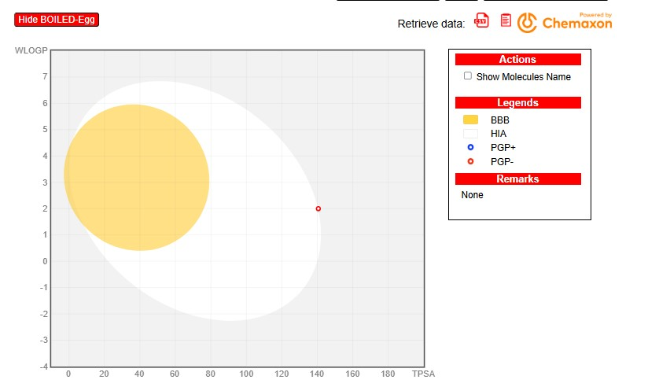
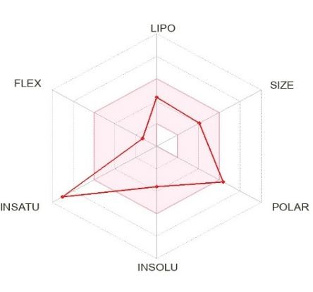
Figure 2. The bioavailability radar of Patuletin through Swiss ADME

.

Table 1. ADME Report of Patuletin assess by swiss ADME
Physicochemical properties |  | Lipophilicity |  | Water solubility |  | Pharmacokinetics |  | Drug likeness |  | Medicinal chemistry
Formula | C16H12O8 | iLOGP | 2.02 | ESOL Log S | -3.61 | GI absorption | Low | Lipinski #violations | 0 | PAINS #alerts | 1
MW | 332.26 | XLOGP3 | 2.14 | ESOL Solubility (mg/ml) | 8.16E-02 | BBB permeant | No | Ghose #violations | 0 | Brenk #alerts | 1
#Heavy atoms | 24 | WLOGP | 2 | ESOL Solubility (mol/l) | 2.46E-04 | Pgp substrate | No | Veber #violations | 1 | Lead  likeness #violation | 0
#Aromatic heavy atoms | 16 | MLOGP | -0.83 | ESOL Class | Soluble | CYP1A2 inhibitor | Yes | Egan #violations | 1 | Synthetic Access-ibility | 3.35
Fraction Csp3 | 0.06 | Silicos-IT Log P | 1.59 | Ali Log S | -4.72 | CYP2C19 inhibitor | No | Muegge #violations | 0
#Rotatable bonds | 2 | Consensus Log P | 1.38 | Ali Solubility (mg/ml) | 6.27E-03 | CYP2C9 inhibitor | No | Bio  availability Score | 0.55
#H-bond acceptors | 8 |  |  | Ali Solubility (mol/l) | 1.89E-05 | CYP2D6 inhibitor | Yes
#H-bond donors | 5 |  |  | Ali Class | Moderately soluble | CYP3A4 inhibitor | Yes
MR | 84.53 |  |  | Silicos-IT LogSw | -3.35 | log Kp (cm/s) | -6.81
TPSA | 140.59 |  |  | Silicos-IT Solubility (mg/ml) | 1.47E-01
 |  |  |  | Silicos-IT Solubility  (mol/l) | 4.43E-04
 |  |  |  | Silicos-IT class | Soluble

PKSCM Prediction:
Table 2 represents pkscm of patuletin. When log S < -2, Pkscm is classified as weakly soluble due to its limited water solubility, which may reduce oral bioavailability. Moderate permeability and a modest absorption potential are indicated by a log Papp value of 0.106. It may experience active efflux from intestinal cells as a substrate, which could affect net absorption and brain penetration. At 0.93 (≈ 8.5 L/kg), the theoretical volume of distribution (VDss) is high, suggesting widespread dispersion in tissues as opposed to blood plasma. Only 10.8% of the drug is unbound in plasma; the remaining 89% is attached to proteins, which reduces the amount of free drug that can be used. Due to polarity or efflux transport, brain penetration is very limited (BB < -1), which leads to very low passive permeability into the central nervous system and little accumulation in pharmacologically meaningful levels.

Table 2. pkCSM pharmacokinetic parameters of Patuletin
Absorption |  | Distribution |  | Metabolism |  | Excretion |  | Toxicity
Water solubility (log mol/L) | -2.987 | VDss (human) (log L/kg) | 0.93 | CYP2D6 substrate | No | Total Clearance (log ml/min/kg) | 0.39 | AMES toxicity | No
Caco2 permeability (log Papp in 10-6 cm/s) | 0.106 | Fraction unbound (human) (Fu) | 0.108 | CYP3A4 substrate | No | Renal OCT2 substrate | No | Max. tolerated dose (human) (log mg/kg/day) | 0.57
Intestinal absorption (human) (% Absorbed) | 78.549 | BBB permeability (log BB) | -1.448 | CYP1A2 inhibitior | Yes |  |  | hERG I inhibitor | No
Skin Permeability (log Kp) | -2.735 | CNS permeability (log PS) | -3.514 | CYP2C19 inhibitior | No |  |  | hERG II inhibitor | No
P-glycoprotein substrate | Yes |  |  | CYP2C9 inhibitior | No |  |  | Oral Rat Acute Toxicity (LD50) (mol/kg) | 2.508
P-glycoprotein I inhibitor | No |  |  | CYP2D6 inhibitior | No |  |  | Oral Rat Chronic Toxicity (LOAEL) (log mg/kg_bw/day) | 2.677
P-glycoprotein II inhibitor | No |  |  | CYP3A4 inhibitior | No |  |  | Hepatotoxicity | No
 |  |  |  |  |  |  |  | Skin Sensitisation | No
 |  |  |  |  |  |  |  | T.Pyriformis toxicity (log ug/L) | 0.29
 |  |  |  |  |  |  |  | Minnow toxicity (log mM) | 3.032
Protox 3.0 interpretation:
According to ProTox 3.0's toxicity prediction, patuletin belongs to toxicity class 5, which is the least harmful, and has a predicted fatal dose of 5000 mg/kg. It exhibits no cytotoxicity, mutagenicity, or neurotoxicity, which is a crucial component of medication safety. Nevertheless, it has likelihood values of 0.7 and 0.88 for cardiotoxicity and immunotoxicity, respectively. Patuletin exhibits hazardous behavior in pathways such mitochondrial membrane potential (MMP), aryl hydrocarbon receptor (AhR), estrogen receptor ligand binding domain (ER-LBD) and estrogen receptor alpha (ER), according to toxicity pathways evaluated. These results imply that patuletin has a relatively safer and less hazardous profile in a number of pathways. As represented in table 3.
Table 3. Toxicity prediction of Patuletin measured across organ toxicity, toxicity endpoints, and toxicity pathways, assessed through ProTox 3.0
Classification | Target | Prediction | Probability
Organ toxicity | Hepatotoxicity | Inactive | 0.72
 | Neurotoxicity | Inactive | 0.87
 | Cardiotoxicity | Active | 0.70
Toxicity endpoints | Carcinogenicity | Inactive | 0.55
 | Immunotoxicity | Active | 0.88
 | Mutagenicity | Inactive | 0.61
 | Cytotoxicity | Inactive | 0.95
Tox21-Nuclear receptor signaling  pathways | Aryl hydrocarbon recptor | Active | 0.90
 | Androgen receptor | Inactive | 0.99
 | Androgen receptor ligand binding domain | Inactive | 0.99
 | Aromatase | Inactive | 0.88
 | Estrogen receptor | Active | 0.77
 | Estrogen receptor ligand binding domain | Active | 0.87
Tox21-Stress response pathways | Heat shock factor response | Inactive | 0.94
 | Mitochondrial membrane potential | Active | 0.89
 | ATPase family AAA domain-containing protein 5 (ATAD5) | Inactive | 0.54

Stoptox interpretation:
As shown in table 4, Patuletin is considered non-toxic for acute inhalation and oral toxicity, with no effects on eye irritation or skin corrosion. However, it shows toxicity in acute dermal toxicity and is identified as a skin sensitizer.

Table 4. Toxicity prediction of Patuletin assessed through StopTox
Toxicity | Acute inhalation toxicity | Acute oral toxicity | Acute Dermal toxicity | Eye irritation and corrosion | Skin sensitization | Skin irritation and corrosion
Prediction | Non toxic | Non toxic | Toxic | Non toxic | Sensitizer | Negative
Confidence | 59% | 74% | 65% | 69% | 70% | 90%
Predicted fragment contribution | 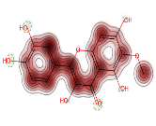 | 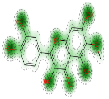 | 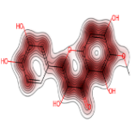 | 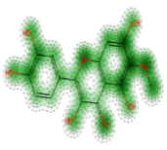 | 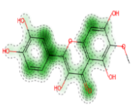 | 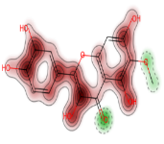

Swiss Target Prediction
Swiss Target Prediction indicates that patuletin predominantly targets 27.6% of lyases, 20% of enzymes and cytochrome P450, 13.3% of kinases, and 6.7% of proteases and oxidoreductases as represented in figure 3. It predicts a high probability of 0.39 with approximately 28 active sites in 3D and 72 in 2D, and forecasts activity on the aldehyde reductase enzyme and various members of the aldose keto reductase family, including C1, C2, C3, and C4 illustrated in table 5.

Figure 3. Predicted target class of Patuletin
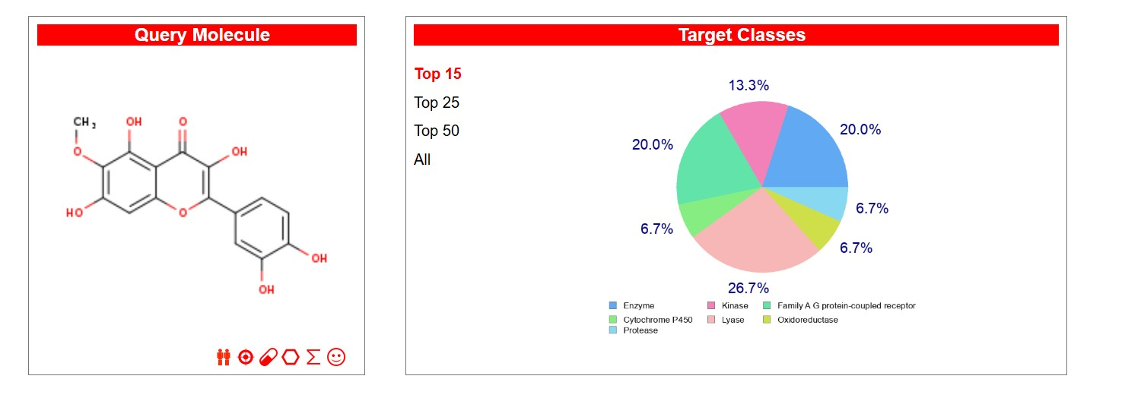
Table 5. Target prediction of patuletin assessed by swiss target prediction
Target | Common name | Uniprot ID | ChEMBL ID | Target Class | Probability* | Known actives (3D/2D)
Aldose reductase | AKR1B1 | P15121 | CHEMBL1900 | Enzyme | 0.395 | 28 / 72
Aldo-keto reductase family 1 member C2 (by homology) | AKR1C2 | P52895 | CHEMBL5847 | Enzyme | 0.121 | 1 / 1
Aldo-keto reductase family 1 member C1 (by homology) | AKR1C1 | Q04828 | CHEMBL5905 | Enzyme | 0.121 | 1 / 1
Aldo-keto-reductase family 1 member C3 (by homology) | AKR1C3 | P42330 | CHEMBL4681 | Enzyme | 0.121 | 1 / 1
Aldo-keto reductase family 1 member C4 (by homology) | AKR1C4 | P17516 | CHEMBL4999 | Enzyme | 0.121 | 1 / 1
Aldehyde reductase (by homology) | AKR1A1 | P14550 | CHEMBL2246 | Enzyme | 0.121 | 1 / 1

Passonline prediction
As table 6 indicated Passonline prediction which highlights various activity targets for inhibitors: aldose reductase inhibitors (0.414), aldehyde oxidase inhibitors (0.838), and several anticancer targets, including Bcl2 antagonist (0.132), Bcl-xL inhibitor (0.076), antioxidant (0.795), apoptosis agonist (0.886), apoptosis antagonist (0.276), and breast cancer-resistant protein inhibitor (0.307). It also identifies key inhibitors: glycerol dehydrogenase (NADP+) inhibitor (0.824), fatty acid synthase inhibitor (0.346), lipid peroxidase inhibitor (0.795), NADPH oxidase inhibitor (0.891), MAP kinase stimulant (0.906), nicotine dehydrogenase inhibitor (0.502), sorbitol-6-phosphate 2-dehydrogenase inhibitor (0.194), telomerase inhibitor (0.398), TNF expression inhibitor (0.414), and TP53 expression enhancer (0.923).
Table 6. Target prediction of Patuletin assessed by Pass Online
Anti-cancer activity | Pa | Pi
Aldehyde oxidase inhibitor | 0,838 | 0,007
Aldose reductase inhibitor | 0,414 | 0,003
Antioxidant | 0,795 | 0,003
Apoptosis agonist | 0,886 | 0,005
Apoptosis antagonist | 0,274 | 0,048
Bcl2 antagonist | 0,132 | 0,033
Bcl-xL inhibitor | 0,076 | 0,015
Breast cancer-resistant protein inhibitor | 0,307 | 0,003
Fatty acid synthase inhibitor | 0,346 | 0,002
Glycerol dehydrogenase (NADP+) inhibitor | 0,824 | 0,001
Lipid peroxidase inhibitor | 0,795 | 0,004
MAP kinase stimulant | 0,906 | 0,002
NADPH oxidase inhibitor | 0,891 | 0,002
Nicotine dehydrogenase inhibitor | 0,502 | 0,027
Sorbitol-6-phosphate 2-dehydrogenase inhibitor | 0,194 | 0,105
Telomerase inhibitor | 0,398 | 0,004
TNF expression inhibitor | 0,414 | 0,052
TP53 expression enhancer | 0,923 | 0,004
Pa: Probably active, Pi: Probably inactive ; Pa > 0.7 are highly probable

Similarity ensemble approach prediction:
Table 7 shows AKR1B1 with values of 0.86 for rats and 0.7 for humans, patuletin demonstrated the greatest (TC) with Aldo-keto reductase family 1 member B1 (AKR1B1). AKR1C21 at 0.62, fatty acid synthase at 0.41, death-associated protein kinase at 0.62, bovine AKR1B1 at 0.46, and arachidonate 12-lipoxygenase (12S-type) at 0.62 were other noteworthy data.
Table 7. Similarity to Patuletin as ligand through SEA (Similarity ensemble approach)
Target Key | Target Name | Description | P-Value | MaxTC
AK1CL_MOUSE | Akr1c21 | Aldo-keto reductase family 1 member C21 | 1.18E-77 | 0.62
ALDR_RAT | Akr1b1 | Aldo-keto reductase family 1 member B1 | 9.99E-56 | 0.86
FAS_CHICK | FASN | Fatty acid synthase | 5.21E-51 | 0.41
DAPK1_HUMAN | DAPK1 | Death-associated protein kinase 1 | 1.65E-13 | 0.62
ALDR_BOVIN | AKR1B1 | Aldo-keto reductase family 1 member B1 | 2.36E-13 | 0.46
LOX12_HUMAN | ALOX12 | Arachidonate 12-lipoxygenase, 12S-type | 3.98E-13 | 0.62
ALDR_HUMAN | AKR1B1 | Aldo-keto reductase family 1 member B1 | 1.99E-08 | 0.7

IMODS Interpretation:
Deformability assesses a molecule's capacity to change shape at its residues, with the Patuletin + aldose reductase complex displaying the highest deformability at a 1.0 index, surpassing the epalrestat + aldose reductase complex. B-factor analysis via normal mode analysis (NMA) and a RMS estimate reveals Patuletin's superiority over elprastat. The covariance matrix reflects residue correlations, showing that Patuletin has strong correlations and fewer anticorrelations, whereas epalrestat presents more anticorrelations but lesser correlations. Results are visually represented in Figures 4 & 5.

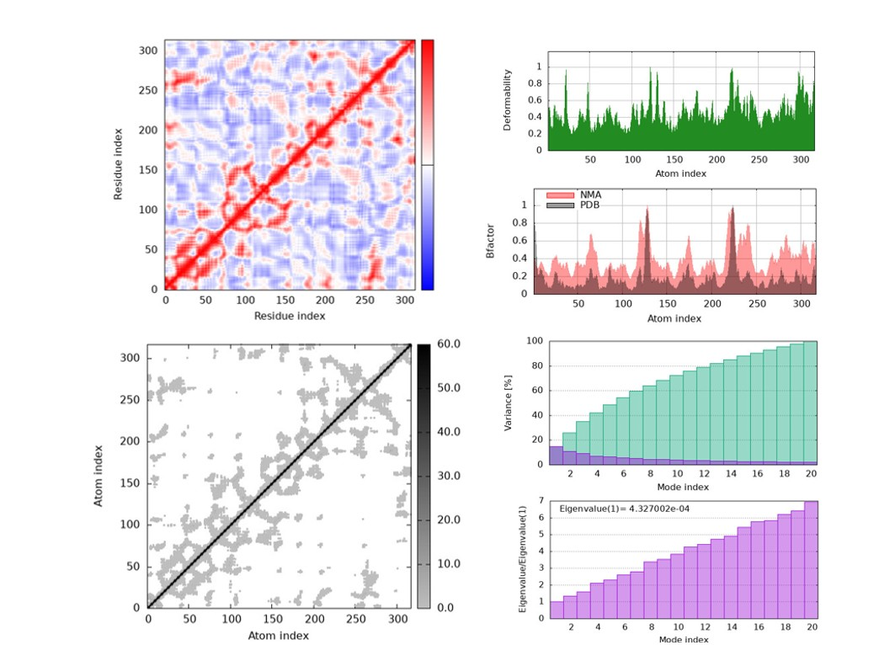
Figure 4. IMOD represented the graph Patuletin binds with aldose reductase
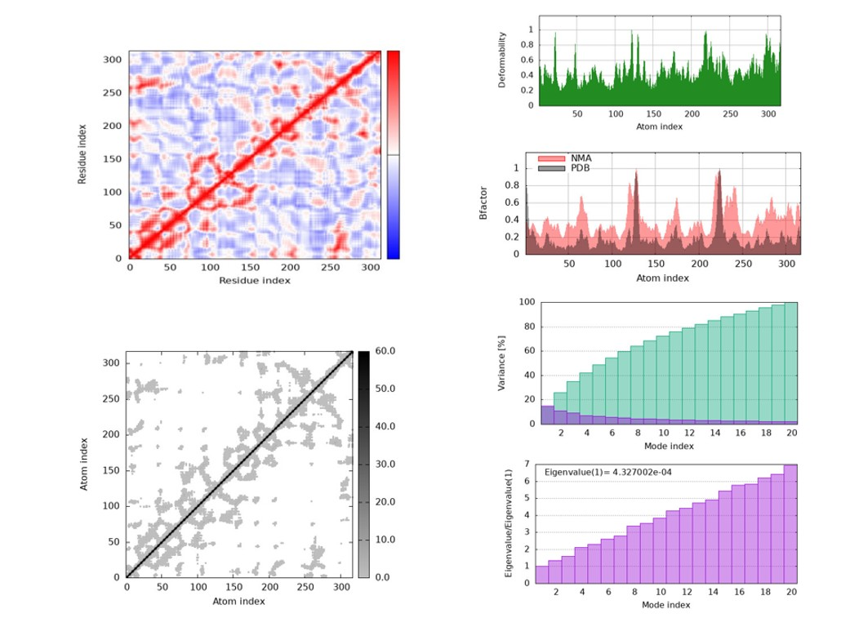
Figure 5. IMOD represented the graph Epalrestat binds with aldose reductase
Molecular docking:
Patuletin has better inhibitory qualities and a higher binding affinity than the popular medication epalrestat, according to molecular docking experiments against 1ADS. Figure 6 with Table 8 displays the binding energy values and table 9 shows structures of ligands, and Figs. 7 to 10 show the docking outcomes. Ramchandran plots reveal molecular similarities, demonstrating that patuletin and epalrestat bind at the same interaction sites (Trp20, Tyr209, Tyr48, ASN160 and Cys298) and patuletin showed similar binding sites as NADP at SER159 and GLN183 as shown in table 10. These results are supported by molecular revalidation using Swiss Dock.

Figure 6. Binding affinities of Patuletin and Epalrestat
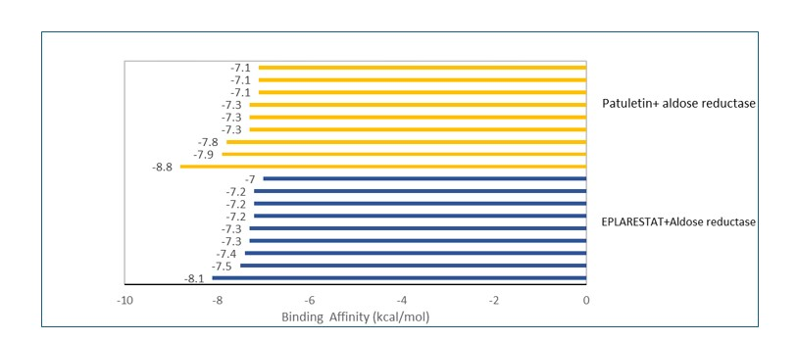
Table 8. Binding affinities of Patuletin and Epalrestat

Ligand | Binding Affinity (kcal/mol) | rmsd/ub | rmsd/lb | Dissociation constant (M)
 | -8.1 | 0 | 0 | 1.14×10-6
 | -7.5 | 8.144 | 4.268 | 3.14×10⁻⁶
Epalrestat + Aldose reductase | -7.4 | 3.261 | 1.976 | 3.71×10⁻⁶
1ADS_(1)_1549120_uff_E=424.34 | -7.3 | 8.036 | 4.43 | 4.40×10⁻⁶
 | -7.3 | 4.984 | 3.038 | 4.40×10-6
 | -7.2 | 9.643 | 5.006 | 5.21×10⁻⁶
 | -7.2 | 7.776 | 5.625 | 5.21×10⁻⁶
 | -7.2 | 5.236 | 3.314 | 5.21×10⁻⁶
 | -7 | 8.902 | 6.127 | 7.30×10⁻⁶
 | -8.8 | 0 | 0 | 3.49×10⁻⁷
 | -7.9 | 7.366 | 1.603 | 1.60×10⁻⁶
Patuletin + aldose reductase | -7.8 | 4.602 | 2.785 | 1.89×10⁻⁶
1ads_5281678_uff_E=471.07 | -7.3 | 4.551 | 2.243 | 4.40×10⁻⁶
 | -7.3 | 5.993 | 3.709 | 4.40×10⁻⁶
 | -7.3 | 5.341 | 2.701 | 4.40×10⁻⁶
 | -7.1 | 3.713 | 2.519 | 6.16×10⁻⁶
 | -7.1 | 7.624 | 3.817 | 6.16×10⁻⁶
 | -7.1 | 8.867 | 3.092 | 6.16×10⁻⁶

Figure 7. Structure of 1ADS docked with ligand (a) NADP (b) Epalrestat (c) Patuletin
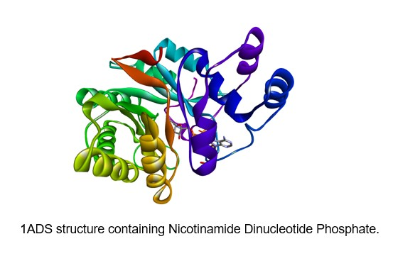
a

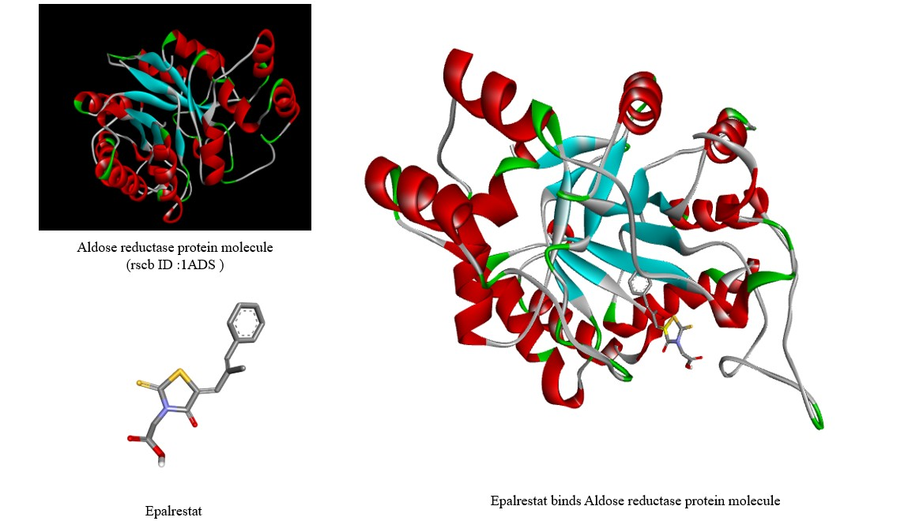
b

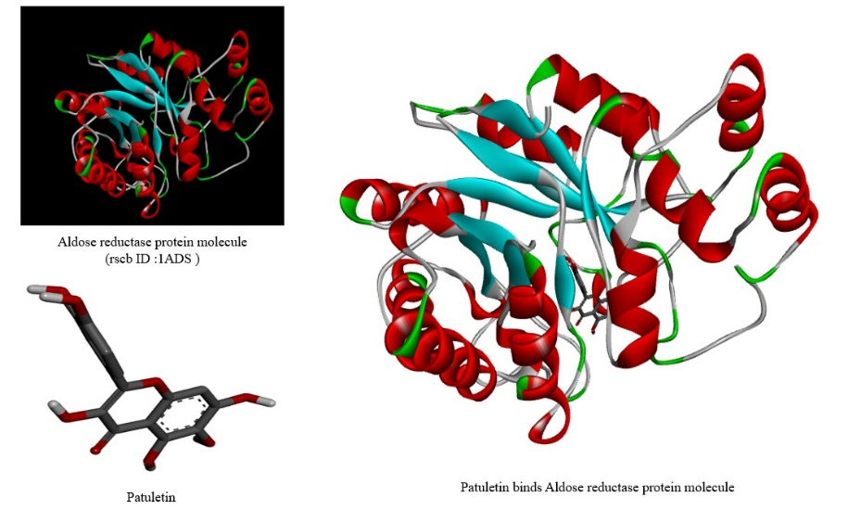

c

Figure 8. 2D Diagram of Active sites of 1ADS binds with respective ligands (a)Nicotinamide dinucleotide phosphate (b) Epalrestat (c) Patuletin
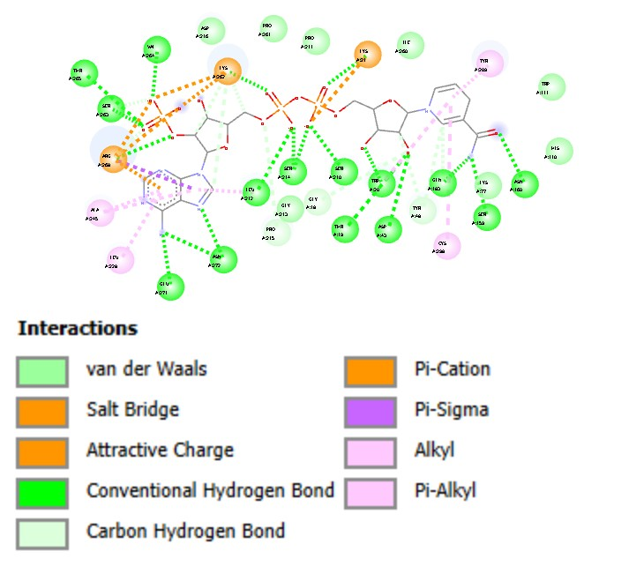
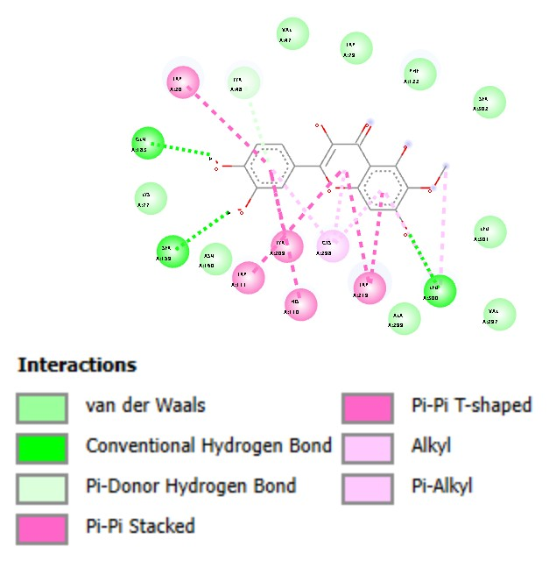
c
a

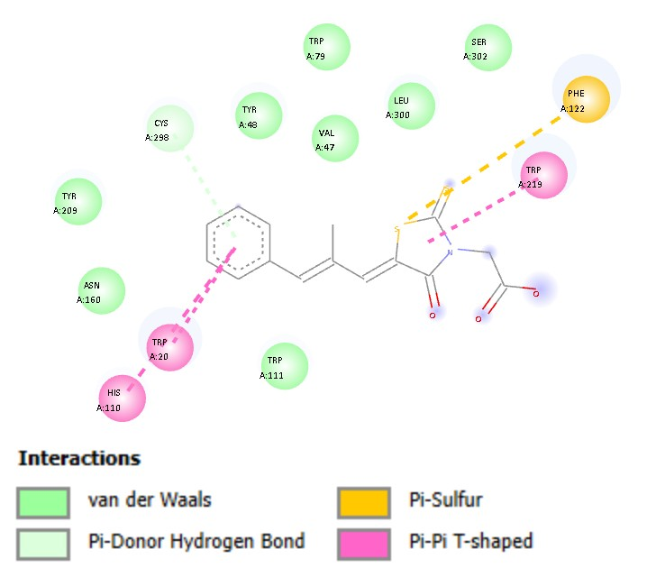
b

Figure 9. 2D Interaction of ligands with aldose reductase
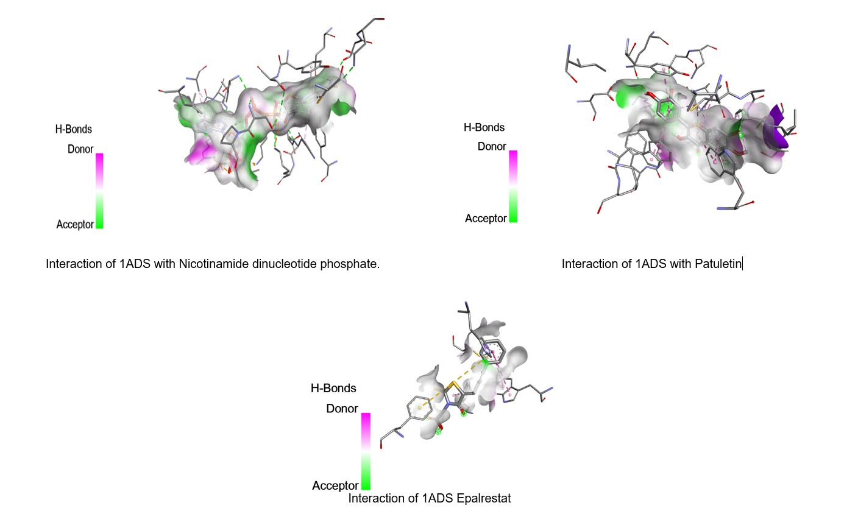
Figure 10. Ramachandran plot all three ligands

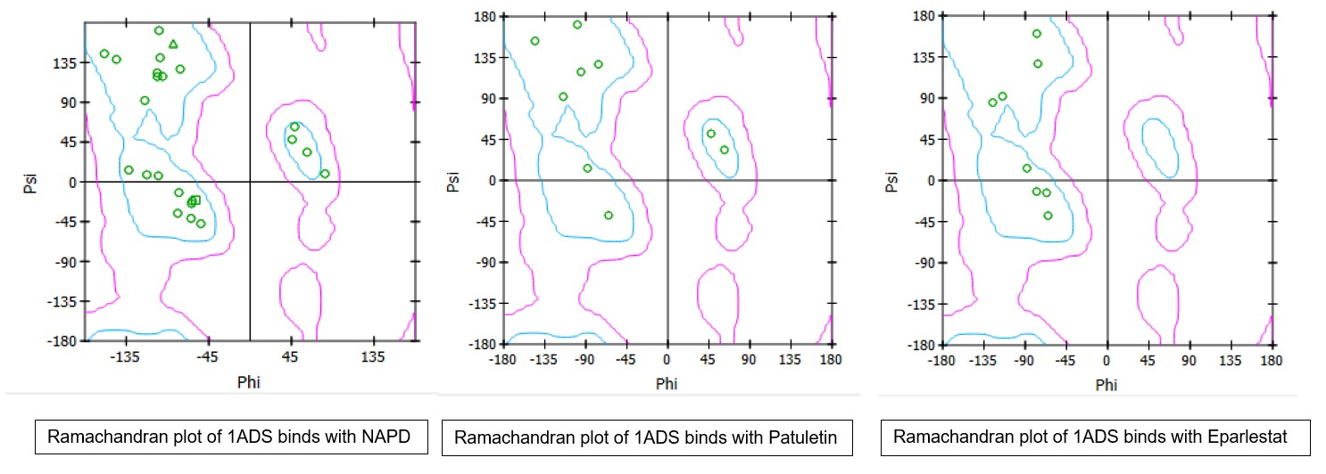

Table 9. SMILES and structure of both ligands
Ligand name | Smile | 2D structure | 3D structure
Epalrestat | C/C(=C\C1=CC=CC=C1)/C=C\2/C(=O)N(C(=S)S2)CC(=O)O | 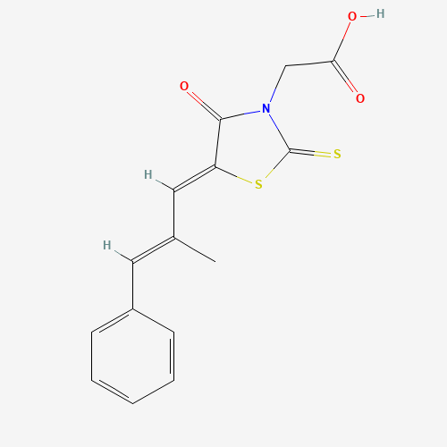 | 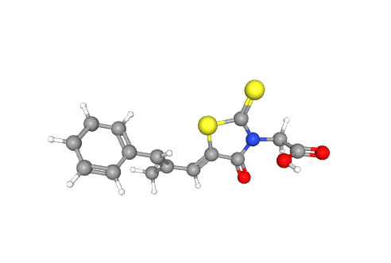
Patuletin | COC1=C(C2=C(C=C1O)OC(=C(C2=O)O)C3=CC(=C(C=C3)O)O)O
Patuletin | COC1=C(C2=C(C=C1O)OC(=C(C2=O)O)C3=CC(=C(C=C3)O)O)O | 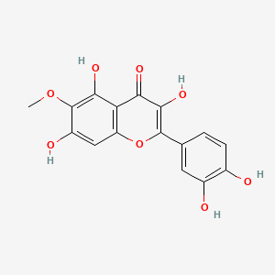 | 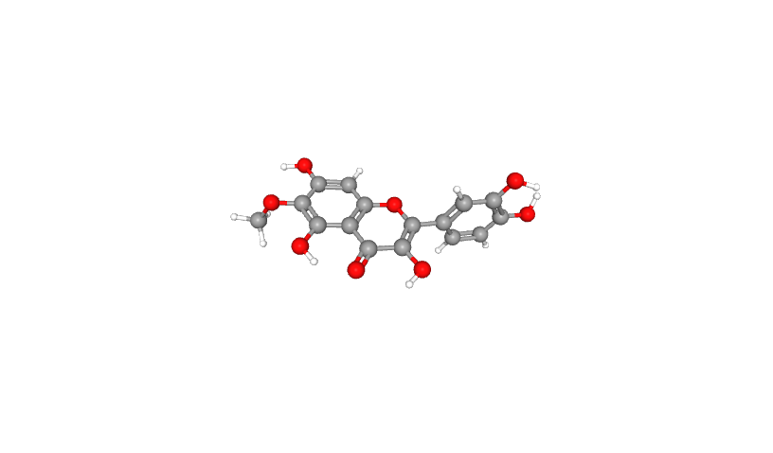

Table 10. Amino acid interaction similarity
Macro-  molecule | Ligand Interaction
Macro-  molecule | Epalrestat |  |  | Patuletin |  |  | NADP
Macro-  molecule | Amino acid interaction | Type | PDB Name | Amino acid interaction | Type | PDB Name | Amino acid interaction | Type | PDB Name
1ADS | TRP20 | Tryptophan | TRP | TRP20 | Tryptophan | TRP | A:Trp20 | Tryptophan | TRP
1ADS | VAL47 | Valine | VAL | VAL47 | Valine | VAL | A:Gly18 | Glycine | GLY
1ADS | TYR48 | Tyrosine | TYR | TYR48 | Tyrosine | TYR | A:Tyr48 | Tyrosine | TYR
1ADS | TRP79 | Tryptophan | TRP | TRP79 | Tryptophan | TRP | A:Thr19 | Threonine | THR
1ADS | HIS110 | Histidine | HIS | HIS110 | Histidine | HIS | A:Lys21 | Lysine | LYS
1ADS | TRP111 | Tryptophan | TRP | TRP111 | Tryptophan | TRP | A:Asp43 | AsparticAcid | ASP
1ADS | PHE122 | Phenylalanine | PHE | PHE122 | Phenylalanine | PHE | A:Leu228 | Leucine | LEU
1ADS | ASN160 | Asparagine | ASN | ASN160 | Asparagine | ASN | A:Asn160 | Asparagine | ASN
1ADS | TYR209 | Tyrosine | TYR | TYR209 | Tyrosine | TYR | A:Tyr209 | Tyrosine | TYR
1ADS | TRP219 | Tryptophan | TRP | TRP219 | Tryptophan | TRP | A:Pro215 | Proline | PRO
1ADS | CYS298 | Cysteine | CYS | CYS298 | Cysteine | CYS | A:Cys298 | Cysteine | CYS
1ADS | LEU300 | Leucine | LEU | LEU300 | Leucine | LEU | A:Ser210 | Serine | SER
1ADS | SER302 | Serine | SER | SER302 | Serine | SER | A:Leu212 | Leucine | LEU
1ADS |  |  |  | LYS77 | Lysine | LYS | A:Ser214 | Serine | SER
1ADS |  |  |  | SER159 | Serine | SER | A:Ser159 | Serine | SER
1ADS |  |  |  | GLN183 | Glutamine | GLN | A:Gln183 | Glutamine | GLN
1ADS |  |  |  | VAL297 | Valine | VAL | A:Ala245 | Alanine | ALA
1ADS |  |  |  | ALA299 | Alanine | ALA | A:Lys262 | Lysine | LYS
1ADS |  |  |  | LEU301 | Leucine | LEU | A:Ser263 | Serine | SER
1ADS |  |  |  |  |  |  | A:Val264  A:Thr265  A:Arg268  A:Glu271  A:Asn272 | Valine  Threonine  Arginine  GlutamicAcid  Asparagine | VAL  THR  ARG  GLU  ASN

Discussion:
Predictions were assessed for originality, reliability, and the capacity to generate high scores for well-known ligand-target interactions. Consistency means that anticipated targets were more likely to be biologically related, while novelty meant choosing only unreported targets. Nevertheless, it was discovered that a single molecule frequently binds to a number of closely related sites, which makes the virtual predictions less specific.

Drug candidates must undergo ADMET (Absorption, Distribution, Metabolism, Excretion, and Toxicity) studies as they move through the preclinical and clinical stages. These studies aim to clarify pharmacokinetic processes and evaluate safety profiles in order to provide vital knowledge that directs risk evaluations for newly developed drugs [17]. A set of criteria known as Lipinski's Rule of Five is employed in drug discovery to forecast a chemical compound's likelihood of having appropriate pharmacokinetic characteristics and high oral bioavailability in humans. The physicochemical characteristics of the ideal compound to cross the blood brain barrier include a molecular weight of less than 500 da, a lipophilicity logP value of approximately 1-3, topological polar surface area (TPSA) of H-bond donors and acceptors below 90–120 Å² is 3–6. In contrast of ideal compound our molecule possesses a molecular weight of 332.26 Da and a logP (lipophilicity) of 2.0 Because it predicts a molecule's capacity to pass through biological membranes, especially the blood-brain barrier, TPSA is a crucial parameter. Topological polar surface area for patuletin is (TPSA) = 140.9Å² - H-bond acceptors and donors = 5 & 8. Despite being soluble and drug-like, the molecule is a P-gp substrate, meaning it is likely effluxed and poorly absorbed. It also has no brain penetration and minimal GI absorption. It may limit bioavailability and cause drug interactions due to its high polarity (TPSA 140.59 Å²) and multiple CYP enzyme inhibitions. Boiled egg representation also predict our molecule is not fall in yellow yolk as well as white area which represents that very low absorption portion in GI and not pass BBB. Therefore, it requires formulation modifications for systemic use, or it might be suitable for local, non-CNS uses.
Distribution profiles, metabolic pathways, excretion routes, absorption rates, and potential toxicity are among the characteristics that SwissADME and pkscm interpret. Utilizing these findings, we can assess the risk of compound. Pkscm indicated limited aqueous solubility. Unless formulation procedures are employed, compounds with log S < -2 are typically regarded as poorly soluble, which may reduce oral bioavailability. Caco-2 permeability is a reflection of intestinal epithelial cells' passive diffusion. A log Papp value of 0.106 indicates moderate permeability, meaning that there may be some absorption potential, but it is not very high. A high anticipated absorption rate indicates that, despite its poor solubility, the substance is probably going to be well absorbed in the human stomach. Since the substance is a substrate, it may actively efflux from intestinal cells, lowering brain penetration and net absorption. The theoretical volume required to hold the entire amount of medicine delivered to disperse while maintaining the same blood concentration is known as volume distribution (VDss). A substance that has a high VDss value is more widely dispersed throughout the body than in blood plasma. Given that 10^0.93 = 8.5, the log VDss was 0.93 ≈ 8.5 L/kg. This enormous volume of distribution indicates that the substance does not remain in plasma but rather spreads widely into tissues. In plasma, around 10.8% of the medication is still unbound, or free. Although it is slightly countered by high tissue distribution, the majority of it (about 89%) is bound to plasma proteins, which may restrict the amount of free medication accessible for pharmacological action and distribution. log Extremely little brain penetration is indicated by BB < -1. This indicates that the medicine is unlikely to successfully pass the blood-brain barrier, most likely as a result of polarity or efflux transport. log Very poor passive permeability into the central nervous system is indicated by this low PS. It is not anticipated that the chemical would accumulate to pharmacologically significant quantities in the central nervous system.
Toxicity prediction from ProTox 3.0 suggest that patuletin posses predicted lethal dose at 5000 mg/kg and predicted toxicity class is 5 which is least toxic. Patuletin toxicity is inactive in terms of neurotoxicity, mutagenicity and cytotoxicity. which is an important aspect of drug safety. Cardiotoxicity and immunotoxicity is active with probability score of 0.7 and 0.88 respectively. Toxicity pathways were also assessed, revealing that patuletin showed toxic behavior in pathways such as the mitochondrial membrane potential (MMP), aryl hydrocarbon receptor (AhR), estrogen receptor ligand binding domain (ER-LBD) and estrogen receptor alpha (ER), These insights suggest that patuletin comparatively safer, with a less toxic profile across multiple pathways.

Toxicity predictions using StopTox was summarized in table 4. The results showed that patuletin is non-toxic for acute inhalation as well as oral toxicity, with no toxicity observed in eye irritation and skin corrosion. However, it exhibited a toxic behavior for acute dermal toxicity, Additionally, patuletin is identified as sensitizers for the skin.
Swiss Target Prediction: The most probable protein targets of bioactive small molecules, particularly in humans and other animals, are predicted using an online tool used in pharmacology and medication development. Swiss Target Prediction combines 2D and 3D chemical similarity comparisons. To predict "which receptors or proteins" a particular chemical may interact with, a comprehensive database of known targets and ligands is used. According to Swiss target prediction, patuletin most likely targets 27.6% of lyases, 20% of enzymes and cytochrome p450, 13.3% of kinases, and 6.7% of proteases, oxidoreductases, and family A G couple protein receptors. It predicts that with higher probability about 0.39 with around 28 (3D) and 72 (2D) active sites. Additionally, it forecasts the aldehyde reductase enzyme and many members of the aldose keto reductase family including C1, C2, C3, and C4.
Simultaneously, passonline prediction indicates the activity target for aldose reductase inhibitors at around 0,414 and aldehyde oxidase inhibitors at 0,838; anticancer activity targets include Bcl2 antagonist 0,132, Bcl-xL inhibitor 0,076, antioxidant 0,795, apoptosis agonist 0,886, and apoptosis antagonist 0,276, protein inhibitor that is resistant to breast cancer (0,307)
Glycerol dehydrogenase (NADP+) inhibitor 0,824 Inhibitor of fatty acid synthase 0,346
inhibitor of lipid peroxidase 0,795, NADPH oxidase inhibitor 0.891 MAP kinase stimulant 0.906, Nicotine dehydrogenase inhibitor 0,502 Sorbitol-6-phosphate 2-dehydrogenase inhibitor 0,194 , Telomerase inhibitor 0,398 TNF expression inhibitor 0,414 TP53 expression enhancer 0,923.

The ligand similarity is also evaluated through SEA similarity ensemble approach. The Tanimoto coefficient, a numerical metric used to compare the molecular fingerprints of two molecules and determine their chemical similarity, is referred to as "Tc" in the Similarity Ensemble Approach (SEA). This coefficient determines the percentage of shared bits or characteristics between two binary chemical representations, which is essential for the SEA method's objective of classifying related substances or forecasting biological activity. Patuletin demonstrated the greatest TC with Aldo-keto reductase family 1 member B1 (AKR1B1) 0.86 for rat and 0.7 for human. Whereas other include Aldo-keto reductase family 1 member (AKR1C21) 0.62, Fatty acid synthase 0.41, death-associated protein kinase 10.62, Aldo-keto reductase family 1 member B1 bovine 0.46, Arachidonate 12-lipoxygenase, 12S-type 0.62.

iMODS (internal coordinates normal mode analysis server): The collective functional movements of biological macromolecules are replicated in internal (dihedral) coordinates using normal mode analysis (NMA). Even with massive macromolecules, iMODS makes it easier to explore these modes and creates workable transition paths between two homologous structures. While implicitly preserving stereochemistry, the unique internal coordinate formulation increases NMA's effectiveness and broadens its range of applications. It is simple to do vibrational analysis, motion animations, and morphing trajectories at various resolution scales in a nearly interactive manner. The server is flexible; while skilled users may alter the model resolution using numerous coarse-grained atomic representations and elastic network potentials, non-specialists can quickly characterize possible conformational changes. Advanced visualization features for collective movements are supported by iMODS, such as an enhanced affine-model-based arrow representation of domain dynamics [18].Deformability measures a molecule's ability to deform at its residues, with the Patuletin + aldose reductase complex showing the most significant deformability. The complex has many peaks with a 1.0 deformability index, compared to the epalrestat +aldose reductase complex. The B-factor, calculated using normal mode analysis (NMA) and an average RMS estimate, indicates that patuletin is similar as that of elprastat. The covariance matrix indicates the correlation between residues, with higher correlations indicating better complexes. Patuletin has a good correlation with a few anticorrelations, while epalrestat has more anticorrelations with a fine correlation. Figure 4 & 5 illustrates these results.
We use aldose reductase structure from rscb site i.e. 1ADS which contain ligand nicotinamides adenine dinucleotide phosphate. Aldose reductase catalyzes the reduced form of nicotinamide adenine dinucleotide phosphate (NADP). It interacts with the sites which are mention in table 11 Trp20, Tyr209 Tyr48, ASN160, Cys298. Aldose reductase protein has been molecularly docked with patuletin and standard epalrestat. Molecular docking studies of patuletin with the aldose reductase enzyme molecule and its two-dimensional interactions with different amino acids on targets are shown in figure 7 to 10. The results of the molecular docking tests for patuletin against 1ADS are shown in Table 10, along with the binding energy and Gibbs energy of the compound. The molecular docking results between Patuletin and the common drug epalrestat were shown in Fig 6. (the binding energy value ΔG is shown in negative kcal/mol). Patuletin is more effective than regular epalrestat based on its inhibitory properties and binding affinity. Ramchandran plots of all molecules showed similarity. It binds with every possible interaction between amino acids that epalrestat demonstrated. All three ligands showed same sites interactions i.e Trp20, Tyr209 Tyr48, ASN160, Cys298. Patuletin showed more potent interaction as it has also similarity with NADP at sites included SER159 and GLN183 Molecular revalidation of molecules has been done through swissdock which shows probably same results.
Conclusion:
In conclusion of study's findings, Patuletin has a higher binding affinity than epalrestat. It may indicate a possible upstream polyol pathway that proceeds to TNF-alpha suppression, lipoxygenase inhibitory action, or apoptosis. The efficacy of patuletin as an aldose reductase inhibitor, which could be a target therapy for anticancer or other disorders involving aldose reductase, needs to be further studied through experiment.
Conflicting interests:
The authors declare no conflicts of interest.
Acknowledgments:
No particular grant from a public, private, or non-profit funding organization was obtained for this study. Special thanks to Tahir Ali Chohan, M. Shoaib Ali Gill, and Hammad Saleem for designing the strategy of online tools utilization.
References:
1. Nijveldt RJ, van Nood E, van Hoorn DEC, Boelens PG, van Norren K, van Leeuwen PAM. Flavonoids: a review of probable mechanisms of action and potential applications123. The American Journal of Clinical Nutrition 2001;74(4):418-25 doi: https://doi.org/10.1093/ajcn/74.4.418.
2. Ateeq M, Shah MR, ul Ain N, et al. Green synthesis and molecular recognition ability of patuletin coated gold nanoparticles. Biosensors and Bioelectronics 2015;63:499-505.
3. Zhu W, Lv C, Wang J, Gao Q, Zhu H, Wen H. Patuletin induces apoptosis of human breast cancer SK‑BR‑3 cell line via inhibiting fatty acid synthase gene expression and activity. Oncology Letters 2017;14(6):7449-54.
4. Zognjani B, Nixha AR, Duran HE, et al. N-substituted phthalimide–carboxylic acid hybrids as dual-targeted aldose reductase inhibitors: Synthesis, mechanistic insights, and cancer-relevant profiling. Bioorganic Chemistry 2025;163:108788 doi: https://doi.org/10.1016/j.bioorg.2025.108788.
5. Penning TM, Jonnalagadda S, Trippier PC, Rižner TL. Aldo-Keto Reductases and Cancer Drug Resistance. Pharmacol Rev 2021;73(3):1150-71 doi: 10.1124/pharmrev.120.000122.
6. Hu Q, Bian Q, Rong D, et al. JAK/STAT pathway: Extracellular signals, diseases, immunity, and therapeutic regimens. Frontiers in Bioengineering and Biotechnology 2023;11 doi: 10.3389/fbioe.2023.1110765.
7. Syamprasad N, Rajdev B, Jain S, et al. Pivotal role of AKR1B1 in pathogenesis of colitis associated colorectal carcinogenesis. International immunopharmacology 2023;119:110145 doi: 10.1016/j.intimp.2023.110145.
8. Balestri F, Moschini R, Mura U, Cappiello M, Del Corso A. In Search of Differential Inhibitors of Aldose Reductase. Biomolecules 2022;12(4) doi: 10.3390/biom12040485 [published Online First: 20220322].
9. Zanoni M, Bravaccini S, Fabbri F, Arienti C. Emerging Roles of Aldehyde Dehydrogenase Isoforms in Anti-cancer Therapy Resistance. Frontiers in Medicine 2022;9 doi: 10.3389/fmed.2022.795762.
10. Cho SJ, Kang KA, Piao MJ, et al. 7,8-Dihydroxyflavone Protects High Glucose-Damaged Neuronal Cells against Oxidative Stress. Biomol Ther (Seoul) 2019;27(1):85-91 doi: 10.4062/biomolther.2018.202.
11. Srivastava SK, Yadav UC, Reddy AB, et al. Aldose reductase inhibition suppresses oxidative stress-induced inflammatory disorders. Chem Biol Interact 2011;191(1-3):330-8 doi: 10.1016/j.cbi.2011.02.023 [published Online First: 20110224].
12. Rauf A, Khan M, Akram Z, et al. Lipoxygenase inhibitory potential of secondary metabolites isolated from Pistacia integerrima: a comprehensive in vitro analysis integrating molecular docking, ADMET and DFT studies. Tradit Med. Res. 2025;10:52.
13. Zhao JX, Yuan YW, Cai CF, et al. Aldose reductase interacts with AKT1 to augment hepatic AKT/mTOR signaling and promote hepatocarcinogenesis. Oncotarget 2017;8(40):66987-7000 doi: 10.18632/oncotarget.17791 [published Online First: 20170510].
14. Bailly C. Moving toward a new horizon for the aldose reductase inhibitor epalrestat to treat drug-resistant cancer. European Journal of Pharmacology 2022;931:175191 doi: https://doi.org/10.1016/j.ejphar.2022.175191.
15. Daina A, Michielin O, Zoete V. SwissADME: a free web tool to evaluate pharmacokinetics, drug-likeness and medicinal chemistry friendliness of small molecules. Scientific Reports 2017;7(1):42717 doi: 10.1038/srep42717.
16. Filimonov D, Lagunin A, Poroikov V. Prediction of activity spectra for substances using new local integrative descriptors. QSAR and Molecular Modelling in Rational Design of Bioactive Molecules. Esin Aki Sener, Ismail Yalcin Eds., Ankara (Turkey) 2005:98-99.
17. Wu F, Zhou Y, Li L, et al. Computational Approaches in Preclinical Studies on Drug Discovery and Development. Frontiers in Chemistry 2020;Volume 8 - 2020 doi: 10.3389/fchem.2020.00726.
18. López-Blanco JR, Aliaga JI, Quintana-Ortí ES, Chacón P. iMODS: internal coordinates normal mode analysis server. Nucleic Acids Res 2014;42(Web Server issue):W271-6 doi: 10.1093/nar/gku339 [published Online First: 20140425].

