Evaluation of Prognostic Factors in Management of Associated COVID-19 Oro-facial Mucormycosis
Prof. Dr. Qais Habeeb Musa
B.D.S, F.I.B.M.S- Department of Oral and Maxillofacial surgery – College of Dentistry – Kerbala University –Iraq. drqaislive@yahoo.com
Lecturer Hamid Ibrahim Mohammed
B. D.S, MSc – Department of Oral and Maxillofacial surgery – College of Dentistry – Kerbala University –Iraq. hamed.a@uokerbala.edu.iq
Lecturer Hamsa Zaki Al-Assadi
B. D.S, MSc – Department of Conservative Dentistry – College of Dentistry – Kerbala University –Iraq. hamsa.z@uokerbala.edu.iq

Abstract
After declaration of corona virus as pandemic in 2019, strong relationship has been showed between the sudden upsurge of mucormycosis occurrence in patients with history of COVID-19. This relation can be explained by: the effect of corona virus on patient immune system, the infection worsens the effect of the underlying predisposing factors such as diabetes mellitus and drugs therapy that were used in treatment of COVID-19 specially corticosteroid. Mucormycosis presented mainly in patient who had comorbid conditions like diabetes, steroid therapy or chemotherapy. This study showed the association between the increase in the prevalence of mucormycosis in patients with COVID-19 and proved the diabetes was the main risk factors for this fungal infection.
The study confirmed there were many factors determined the prognosis in the management of mucormycosis first of them is the early diagnosis which depends on high index of clinical suspicion, accurate procedures for diagnosis confirmation such as biopsy, fungal culture media, radiological examination by CT scan or MRI, early initiation of antifungal therapy either Amphotericin- B or Liposomal Amphotericin- B as soon as the diagnosis is confirmed and aggressive surgical debridement of all infected tissue .
Keywords: Mucormycosis, COVID-19, Amphotericin-B, Diabetes Mellitus

Introduction:
Mucormycosis is an angio-invasive fungal infection related with high percentage of morbidity and mortality, mucorales is the fungi that cause mucormycosis (1). The incidence of mucormycosis increase in patients with diabetes mellitus, corticosteroid therapy, organ transplants and haematological malignancy (2). In the Asian continent, diabetes mellitus is considered the most common risk factor (3).
The most common form of this fungal infection is Rhino-orbital-cerebral mucormycosis(4). Spread from the orbit to the brain takes place via contiguous or hematogenous dissemination and/or to the cavernous sinus via venous drainage (5).
There is globally increasing in the incidence of mucormycosis, but the rise is very high among patients with uncontrolled diabetes mellitus in India and China (6).
The mucorals spores germinate in patients with COVID-19 which is facilitated by the following primary reasons: hypoxia, diabetes, metabolic acidosis and decrease white blood cell phagocytic activity because of the immunosuppression and association with other risk factors such as prolonged hospitalization (7). Mucormycosis in diabetic patient may be fatal and causes severe complications if it is not treated timely and adequately (8).
Mucorales is neutralized by immune system through phagocytosis, chemotaxis and killing by the oxidative and non-oxidative mechanisms. In diabetes mellitus, the patients lack these normal function of immune cells and are considered as immunocompromised state (9).
Unfortunately, treatment with corticosteroids in patients COVID‑19 has showed cause for a dramatic outpouring of hyperglycemia and ketoacidosis, which permitting the fungus to have a bountiful culture media (10).
The nasal turbinates are considered the initial site for ROCMs, aggressive further proliferation occurs to involve the sinus, palate, orbit and brain with strong attraction for blood vessels(11). The spread of the infection from sinus leads to osteomyelitic bone, further spread to the orbital content and brain by the orbital rout. Spread of the infection to the cavernous sinus and sphenoid sinuses result in cranial nerves palsy (12). Facial pain, headache, swelling of nasal and periorbital regions, bleeding from nose, loss of vision accompanied by facial paralysis and nasal discharge that consist from amount of reddish‑black nasal turbinate is considered the main manifestations of mucormycosis, the patient who remains untreated result in progression of the infection to the cranial region that resulted in many symptoms include blindness, lethargy and seizures usually followed by death (13).
The diagnosis of mucormycosis is done by histopatholagical examination and /or fungal culture, sinus biopsies, tissues biopsies and orbital tissue biopsies are used as specimens for histopathology and culture examination (14). Extent of tissue involvement by mucormycosis is defined by the role of CT scan and MRI, which is very decisive for effective debridement of the involved tissue by infection (15). Difﬁculties in early diagnosis, pathogenetic mechanisms and differences in host–fungus interactions had been related to the higher degree of difﬁculty to recuperate this desolating infection (16).
A multimodal approach is considered as base for successful management of mucormycosis which including ; the reversal of underlying predisposing factors, early administration of optimal dose of an active antifungal therapy, infected tissue should be completely removed(17).The first choice active antifungal drug is Amphotericin B (18). Destruction of fungal cell wall is obtained by of Amphotericin B that usually prescribed in higher doses (5–10 mg/kg), reduction in the risk of nephrotoxicity is obtained by administrating the liposomal formulation (10).
Surgery must be very aggressive; the removal of necrotic tissues is extended until the perfused tissue is encountered by the surgeon. Excision of palate, nasal cartilage and exenteration of orbital contents may be required in advanced cases of ROCM (19).
The prognosis of mucormycosis leans on multiple factors including the patient general health at the time of diagnosis, the early detection and the site of infection (20).

Materials, patients and method
This study was done at oral and maxillofacial department in Al-Hussien Teaching Hospital in Kerbala Governorate –Republic of Iraq. From period of time extended from January 2019 until end of December 2021 (this period of time was divided in to two divisions: One before the declaration of COVID-19 as pandemic in March 2020; from January 2019 until declaration of pandemic in 11 march 2020, another from time of declaration of pandemic to the end of December 2021).
Diagnosis
Clinical examination
Clinical examination was done by MDT (multidisciplinary team) that involved from; maxillofacial surgeon, ophthalmologist, otolaryngologist, neurologist and internal medicine physician. Clinical examination was done carefully specially in patient with clinical manifestations like (palatal ulceration, palatal black discoloration, sequestrum formation in the maxillary alveolus and palate, patches of black discoloration over skin of nose, diplopia, periorbital erythema and cellulitis). Pupillary reaction test and ocular motility also involved in the clinical examination.
Laboratory tests
Once clinically suspected, routine laboratory test was done that include: complete blood count, fasting blood sugar, HbA1c (Glycated heamoglobine) and kidney function test include electrolyte.
Diagnostic procedure:
1- Diagnostic nasal endoscopy.
2- Contrast Enhanced Computed Tomography for paranasal sinuses and nose.
3- Contrast Enhanced Magnetic Resonance Image for brain, orbit and face.
4-Biopsy: which revealed the angioinvasion, hemorrhagic infarction, coagulation necrosis
5-Culture media (fungal culture )

Management
*Strict control of blood sugar level
*Antibiotics (when there was superadded infection evidence only).
*Extensive surgical debridement for removal of all necrotic tissues that involved by fungal infection, which included (alveolar process with teeth resection, Culd-wel-Luck approach in maxillary sinus involvement, palatal resection by open maxillectomy, partial maxillectomy to total maxillectomy, resection facial skin and muscles and orbital exenteration). Image from the CT and/or MRI helped in defining the extent of surgery. Extension of surgical detriment was determined by MDT.
Antifungal drugs:
1- D-AmB (Amphotericin B deoxycholate) was described in dose (1-1.5 mg/kg/day) that continued for 3-6 weeks.
2- L-AmB (Liposomal Amphotericin B) was described in dose (5-10mg/kg/day) that continued for 3-6 weeks, L-AmB was used when it available or when the use of D-AmB should be avoided according to the kidney function test.

Methods for preparation and using of antifungal medication
Amphotericin B deoxycholate (D-AmB)
1-Before each controlled infusion of Amphotericin B., one liter of normal saline with one amp. of KCL (20mEq of potassium chloride) over 2 hours was gave to the patients.
2- Each vial (50 mg of D-AmB) was reconstituted with 10 ml of injection water for and should be immediately shake well to produce a colloidal solution with 5mg/ml.
3- Further dilution was obtained by 5% dextrose (500 ml) to reach the concentration of 100 micrograms/ml.
4-Infusion was done over 2- 4 hours or longer if not tolerated ( 10 ml was the initial test dose that means 1 mg over 20-30 minutes).
5- After dilution, the infusion begun immediately and covered with black sheet to protect from light.
6- Flush existing intravenous line with glucose 5% was done because of the drug is incompatible with sodium chloride solution

Liposomal Amphotericin B(L-AmB)
1- Vial (50 mg of L-AmB) was reconstituted with 10 ml of injection water and to generate the liposomes the solution should be shake well for 2- 5 minutes.
2-After the reconstitution all the vial, 10 ml syringe was filled with reconstituted L-AmB.
3-The needle was removed and the syringe nozzle was applied by 5-micron filter and the content was emptied in to 5% dextrose (200 cc).
4- Infusion of L-AmB over 2-3 hours was done (1 mg over 10 minutes was the initial dose)
5- Flush existing intravenous line with glucose 5% was done because of the drug is incompatible with sodium chloride solution

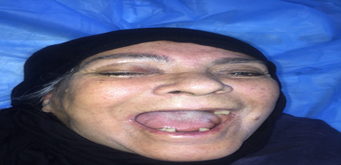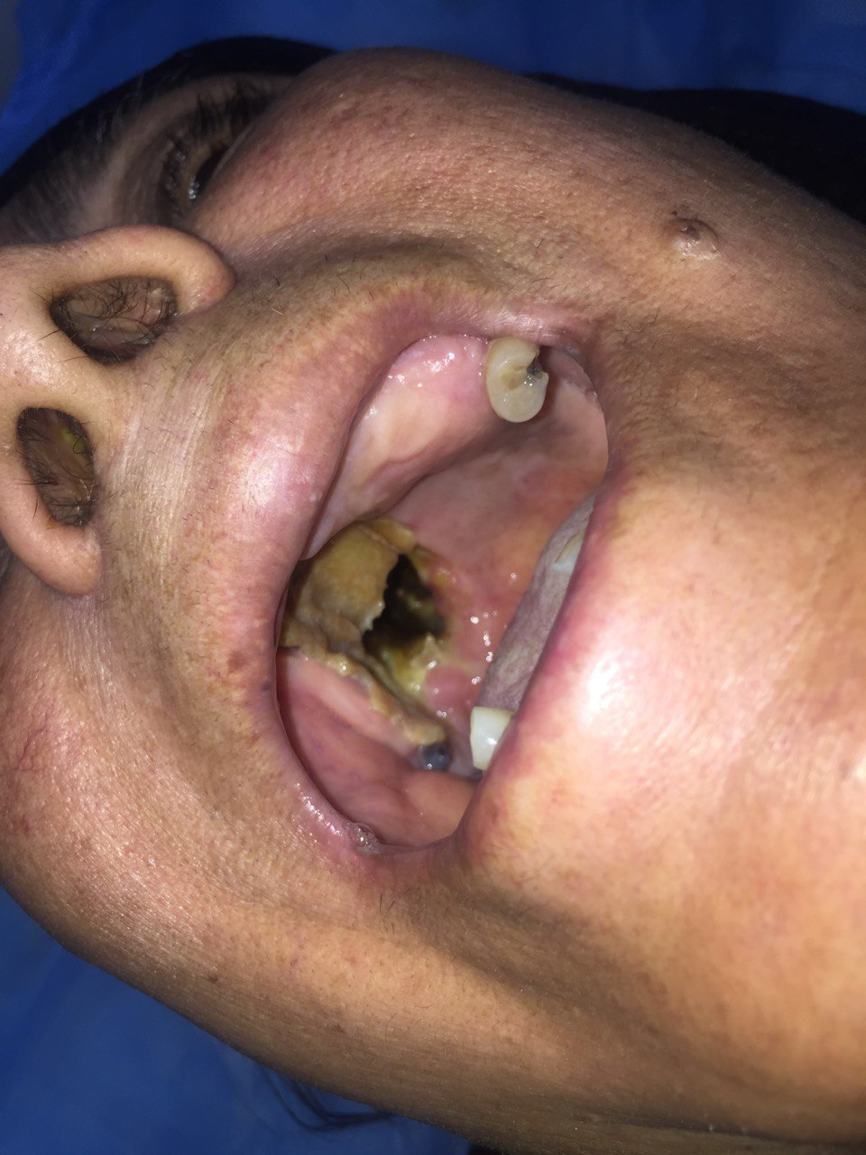
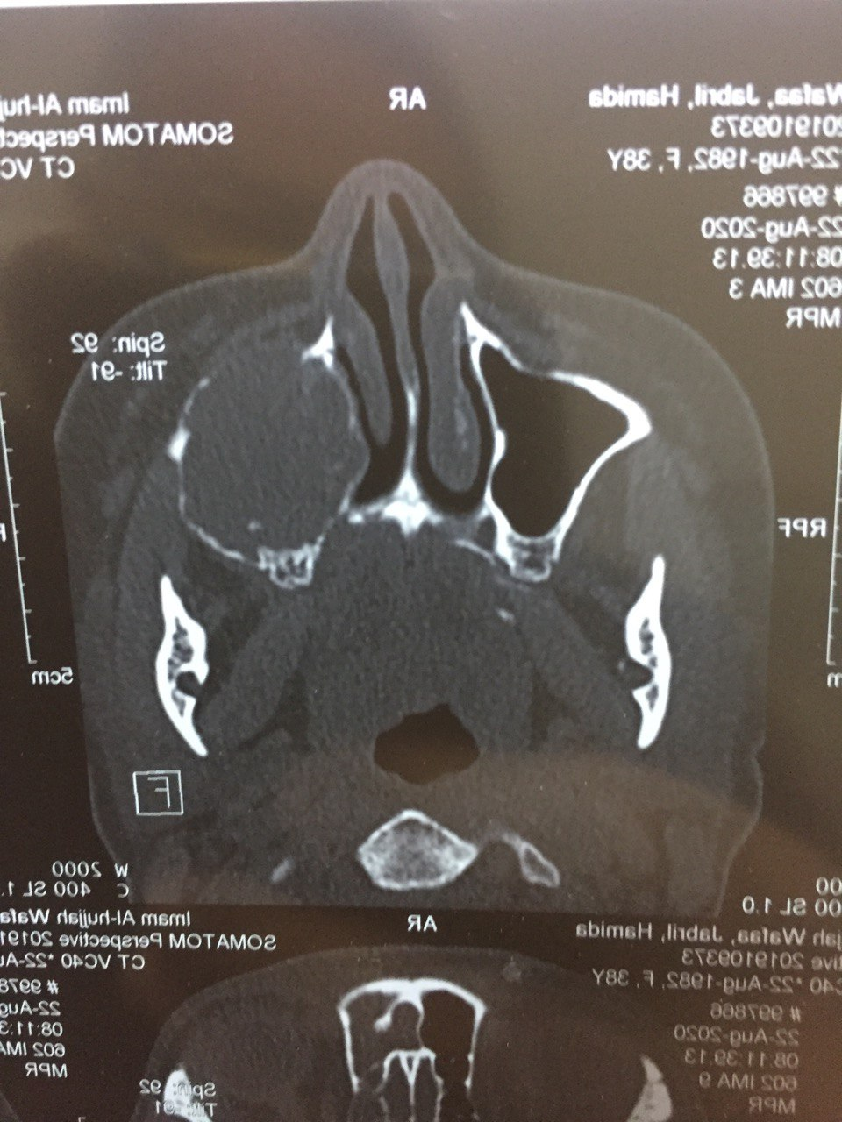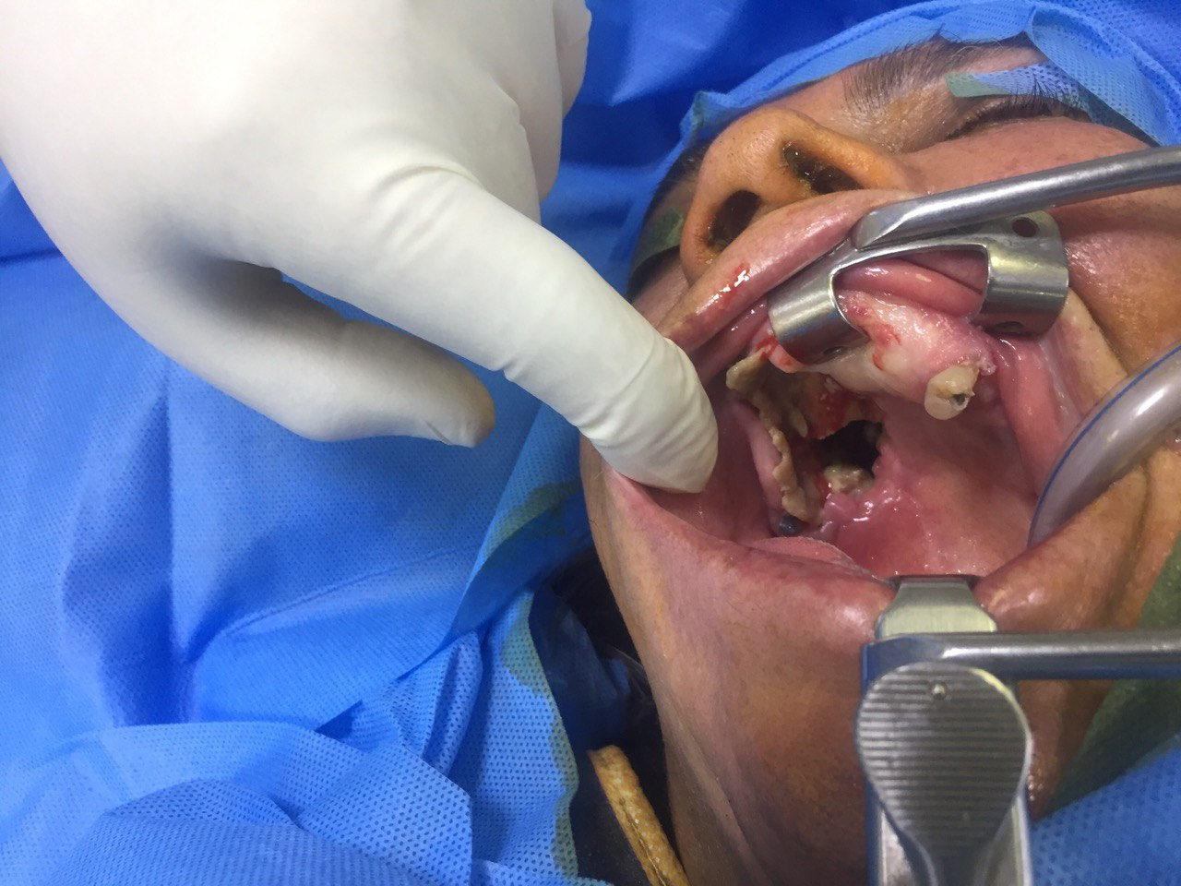
Cases (1): 64 years old female patient with destructive palate and orbital extension as show by clinical presentations and CT scan.

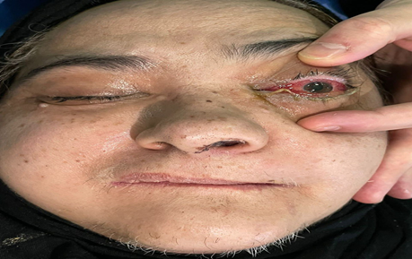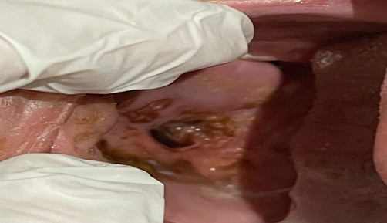
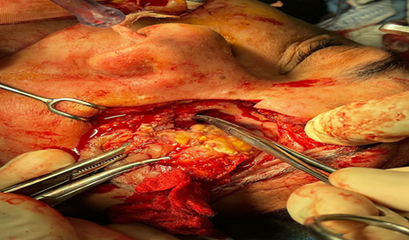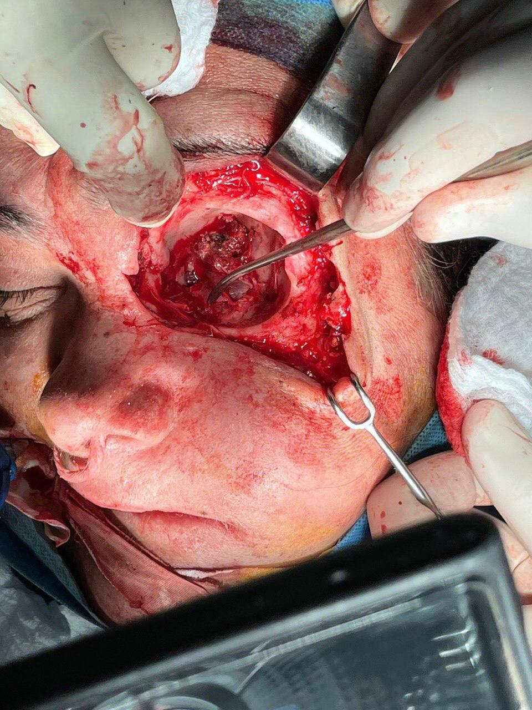
Case (2) :59 years old female patient with mucormycosis shows orbital (eye involvement) and palatal ulcerations, was treated by resection facial skin and muscles and orbital exenteration)

Results
Total no. =39 |  |  | Male | Female
 |  |  | 21 (48.85%) | 18 (41.15%)
Age of patients | Age groups | No. | Male | Female
Age of patients | <30 years | 2 | 2 | -
Age of patients | 30-60 years | 30 | 16 | 14
Age of patients | >60 years | 7 | 3 | 4
Comorbid condition | Type | No. | Male | Female
Comorbid condition | Diabetes mellitus | 35(89.76%) | 19 | 16
Comorbid condition | Glucocorticosteroids drug | 2(5.12%) | 1 | 1
Comorbid condition | Chemotherapy | 2(5.12%) | 1 | 1
Total number of patients that participated in this study was 39 patients; 21 males and 18 females. Age of patient was divided into the three age groups (<30 years, 30-60 years and >60 years), greater incidence was recorded in (30-60 years) group.
Table (3-1): Age and gender distribution for patients and comorbid conditions

Mucormycosis and association with COVID-19:
Before declaration of pandemic, there was 7 patients, while after spread of corona virus disease) there was 32 patients that is mean there is about 4.5-time increase in the disease after pandemic of corona virus.

Table (3-2): The types of mucormycosis and it relation to Covid-19
With history of Covid -19 |  | 32 | M : 17
 |  | 32 | F: 15
Without history of Covid -19 |  | 7 | M : 4
 |  | 7 | F : 3
Mucormucosis onset | Time of onset of Covid-19 |  | No. | Gender
Mucormucosis onset | At the time of diagnosis |  | 5 | M: 3
Mucormucosis onset |  |  | 5 | F: 2
Mucormucosis onset | After admition at hospital |  | 12 | M: 7
Mucormucosis onset |  |  | 12 | F: 5
Mucormucosis onset | After recovery |  | 15 | M: 7
Mucormucosis onset |  |  | 15 | F: 8
Type | Type according to anatomical region involved |  | No. | Site
Type | Oro antral mucormycosis |  | 15 | Palate , alveolar process , maxillary sinus
Type | Rhino sinus mucormycosis |  | 11 | Nose , maxillary sinus
Type | Rhino-orbital-cerebral mucormycosis (ROCM) |  | 13 | Nose , maxillary sinus, orbit, cranial cavity

Clinical manifestations, investigations and management
All patients that participated in this study were diagnosed by history, carful clinical examination, radiological examination (CT scan and /or MRI), culture and biopsy, and all of them were managed by aggressive surgical debridement and high dose of antifungal therapy.
Table 3-3: Clinical manifestations of different type of mucormycosis, investigations and management
Site of mucormycosis | No. | Comorbid condition | Clinical manifestations (all or some ) | Investigations | Surgical debridement | Antifungal therapy
Oro antral mucormycosis | 15 | 12 diabetics, 2 on steroid drugs and 1 on chemotherapy | Teeth mobility, gingival ulceration, palatal ulceration, dental pain, necrotic alveolar bone (sequestrum) facial pain, nasal blockage,  para-sinusal pain | CT scan , biopsy and fungal culture – direct smear | Aggressive surgical debridement (alveolar bone resection with mobile teeth, curettage of maxillary sinus or partial maxillectomy ) | Amphotericin B or liposomal Amphotericin B ( according to availability )
Rhino sinus mucormycosis | 11 | 10 diabetics and 1 on chemotherapy | Black colored turbinates, erythema of nasal mucosa, stuffy nose, facial pain, nasal blockage,  para-sinusal pain, facial erythema | Diagnostic nasal endoscopy , CECT for nose and paranasal sinus and biopsy | Aggressive surgical debridement of necrotic tissue, alveolar bone resection or partial maxillectomy | Amphotericin B or liposomal Amphotericin B ( according to availability )
Rhino-orbital- cerebral (ROCM) | 13 | 13 diabetics ( all of them are uncontrolled | Diplopia,  Periorbital (erythema edema, cellulitis), corneal numbness, necrotic skin lesion (Escher),  facial pain, black colored turbinates,  black purulent discharge, change in level of consciousness, coma | Contrast enhanced magnetic resonance image (CEMRI) and biopsy | Aggressive surgical debridement of necrotic tissue (skin or muscle), partial maxillectomy, orbital exenteration. | Amphotericin B or liposomal Amphotericin B ( according to availability )

Patient's survival, mortality and prognosis
Death was recorded in 4 cases, survived patients were 35 after follow up for 6 months. In relation to prognosis death was not recorded in period before declaration of pandemic COVID-19, all death cases were reported in period after declaration of pandemic and all of them were recorded in patients with ROCM .
Table 3-4: Survival, mortality and prognosis in patients with mucormycosis before pandemic Covid-19
Site mucormycosis | No. of cases | No .of survival patients | No. of mortal patients | Prognosis
Oro antral | 4 | 4 (100%) | 0 | Excellent
Rhino sinus | 2 | 2(100 % ) | 0 | Excellent
Rhino-orbital- cerebral (ROCM) | 1 | 1(100%) | 0 | Excellent
Total | 7 | 7( 100%) | 0 | Excellent

Table 3-5: Survival, mortality and prognosis in patients with mucormycosis after pandemic Co-19
Site mucormycosis | No. of cases | No .of survival patients | No. of mortal patients | Prognosis
Oro antral | 11 | 11 (100 % ) | 0 | Excellent
Rhino sinus | 9 | 9(100 % ) | 0 | Excellent
Rhino-orbital- cerebral (ROCM) | 12 | 8(66.6%) | 4 | Moderate
Total | 32 | 28( 87.5 %) | 4(12.5%) | Very good

Discussion
In our study, the increase in the incidence of mucormycosis and association of it with COVID -19 had been showed by comparison between 2 periods before and after declaration of COVID-19. Evidence-based review and literature search reveal that reports of mucormycosis from India and globally have observed a sudden upsurge recently with a definite relation with corona virus disease (21). The study showed the occurrence of mucormycosis in patient either in active status of Covid-19 or after recovery. Large number of cases with mucormycosis have been reported in patients with active COVID-19 infection as well as those post infections (22).
The association between the incidence of mucormycosis and COVID-19, is explained by effect of corona virus on the immunological system of infected patient which result in the impairment of cell mediated response (23), also the drugs that were used in treatment of corona virus disease such as antibiotic and steroid. Patients that diagnosed and treated for COVID-19 with corticosteroid therapies and broad-spectrum antibiotics are considered at the highest risk for developing fungal infection (24).
The majority of patients participated in this study had history of diabetes mellitus, all patients in this study with history of COVID-19 were diabetic patient, our study confirmed the diabetes mellitus was the main risk factor . In the international series reported by Hoengl et al., diabetes mellitus was the more predominant risk factor for corona virus disease associated mucormycosis in cases reported from India (25).
Steroid therapy was used in treatment of patient with COVID-19, which is considered another risk factor for mucormycosis. Treatment of COVID-19 with steroid therapy can leads to an exacerbation of hyperglycemia and eventually leads to fungal infections such as mucormycosis, at the same time cause worsening of glycemic control in diabetic patients (26).
The definite diagnosis of this fungal infection was depend on the high index of suspicion specially in patient with diabetes mellitus or on steroid therapy, clinical examination, quick evaluation of clinical symptoms, histopathology, direct microscopy, culture, CT-scan and MRI.A quick evaluation of clinical symptoms, identification of host variables and a strong index of suspicion are required for the diagnosis of mucormycosis (26). During clinical examination of patients in this study, the intraoral or extraoral clinical manifestations like palatal ulceration, teeth mobility, sequestrum formation, unhealed extraction socket, nasal fistula, black nasal discharge, black discoloration, diplopia or periorbital pain and cellulitis were considered an indexes for high suspicion of mucormycosis specially in patient with diabetes or history of COVID -19 and biopsies were done to confirm diagnosis. Specimen from surgical exploratory site is the only (invasive) option for confirmation of diagnosis (27). All patients were sent for CT scan and/or MRI. When there is a clinical suspicion of mucormycosis, the diagnosis confirmation requires the radiological examination, a computed tomography of the orbit and maxilla should be done (28).
After confirmation of diagnosis, our patients were treated immediately by antifungal therapy and aggressive surgical debridement, which was depend on the extension of fungal invasion that was detected by radiological image (CT scan or MRI) and the decision of MDT, that varied in patients from alveolar process with teeth resection to the orbital exenteration . The extension of the surgical procedure is usually determined by the extent of the fungal infection, which is assessed by both clinical and radiographic examinations by using CT scan and/or MRI (29). Aggressive surgical debridement of the area with fungal invasion was performed immediately as soon as possible when the diagnosis was confirmed that improved the survival rate. Survival rates are improved by an aggressive surgical approach (30).
An early aggressive surgical debridement of the infected craniofacial tissues is the foundation of successful treatment of rhino orbital cerebral mucormycoses; includes resection of infected tissues of the face (skin and muscle), infected skin of the nose, maxillary sinus and orbital exenteration (31).
Management success and prognosis of mucormycosis in our study with six months follow up, depended on early diagnosis, strict control of hyperglycemia, early administration of antifungal therapy and aggressive surgical debridement. Immediately surgical debridement and early administration of anti-fungal therapy, had been shown clearly to improve the prognosis and decrease the mortality (32). Series reported by Hongil et al., mortality rates were lower in patients with ROCM who had adjunctive surgical treatment (4/28, 13.8%) versus patients treated by antifungals alone (5/8, 62.5%) (25).
Amphotericin B or Liposomal Amphotericin B were used for our patients, the selection of drug depended on the drug availability and state of renal function. Renal function test for monitoring blood urea and serum creatinine was done for patients on antifungal therapy. Rodriguez-Morales et al., recommend the high dose liposomal amphotericin B is the first line of therapy whenever there is suspicion of mucormycosis (33). Amphotericin B deoxycholate was used in 1-1.5 mg/kg/day and Liposomal Amphotericin B was used in high dose (5-10 mg/kg/day) specially in ROCM. The recommended dose of liposomal Amphotericin B is 5 mg/kg/day (33).
Death was recorded in our patients with advance stage of fungal infection because of the incorrect diagnosis due to the disease was examined by general dentist who has not enough experience or not familial with clinical features of this fatal disease. Systematic referral procedures for specialist surgeon are essential for improvement of prognosis and decrease the mortality. All death cases were reported in patients with ROCM with history of uncontrolled diabetic, some of them were in coma because of delay in diagnosis that leads to dissemination of fungal infection to the brain. Precious time have been wasted by general dental practitioners who had low index of suspicion for mucormycosis in performing mobile teeth extraction and root canal treatment that leads to delay the inception of definitive mucormycosis treatment and thus resulting in a poor or fatal outcome for the patient (34).

Conclusion:
Mucormycosis is strongly associated with COVID-19, high number of cases had been reported after declaration of pandemic specially in second wave. Diabetic patients at great susceptibility for developing mucorsycosis and diabetes mellitus was the main risk factor in our study. Better prognosis was obtained by early diagnosis, accurate diagnostic procedures, early initiation of antifungal therapy and aggressive surgical debridement.

References
- Jeong, W.; Keighley, C.; Wolfe, R.; Lee, W.L.; Slavin, M.A.; Kong, D.C.M.; Chen, S.C.A. The epidemiology and clinical manifestations of mucormycosis: A systematic review and meta-analysis of case reports. Clin. Microbiol. Infect. 2019, 25, 26–34.
- Prakash, H.; Ghosh, A.K.; Rudramurthy, S.M.; Singh, P.; Xess, I.; Savio, J.; Pamidimukkala, U.; Jillwin, J.; Varma,S.;Das,A.;etal. Aprospective multicenter study on mucormycosis in India: Epidemiology,diagnosis, and treatment. Med. Mycol. 2018.
- Chakrabarti, A.; Das, A.; Mandal, J.; Shivaprakash, M.R.; George, V.K.; Tarai, B.; Rao, P.; Panda, N.; Verma, S.C.; Sakhuja, V. The rising trend of invasive zygomycosis in patients with uncontrolled diabetes mellitus. Med. Mycol. 2006, 44, 335–342.
- Kauffman, C. A., Vazquez, J. A., Sobel, J. D., Gallis, H. A., McKinsey, D. S., Karchmer, A. W., ... & National Institute for Allergy and Infectious Diseases (NIAID) Mycoses Study Group. (2000). Prospective multicenter surveillance study of funguria in hospitalized patients. Clinical Infectious Diseases, 30(1), 14-18.‏
- Teixeira, C. A., Medeiros, P. B., Leushner, P. & Almeida, F. 2013. Rhinocerebral mucormycosis: literature review apropos of a rare entity. Case Reports, 2013.
- Ambrosioni, J.; Bouchuiguir-wafa, K.; Garbino, J. Emerging invasive zygomycosis in a tertiary care center: Epidemiology and associated risk factors. Int. J. Infect. Dis. 2010, 14, e100–e103.
- Awadhesh Kumar Singh, Ritu Singh, Shashank R. Joshi,Anoop Misra. Mucormycosis in COVID-19: A systematic review of cases reported worldwide and in India: Diabetes & Metabolic Syndrome: Clinical Research & Reviews 15, (2021), 102146.
- Dhandapani M, Manne M, Mohammed L. Risk of Mucormycosis in Diabetes Mellitus: A Systematic Review. Cureus. 2021 Oct 16;13(10):e18827. doi: 10.7759/cureus.18827. PMID: 34804684; PMCID: PMC8592794.
- Mengji AK, Yaga US, Gollamudi N, Prakash B, Rajashekar E. Mucormycosis in a surgical defect masquerading as osteomyelitis: a case report and review of literature. Pan Afr Med J. 2016;23:16.
- Sundaram N, Bhende T, Yashwant R, Jadhav S, Jain A. Mucormycosis in COVID-19 patients. Indian J Ophthalmol 2021; 69:3728-33.
- Veisi A, Bagheri A, Eshaghi M, Rikhtehgar MH, Rezaei Kanavi M, Farjad R. Rhino‑orbital mucormycosis during steroid therapy in COVID‑19 patients: A case report. Eur J Ophthalmol 2021;11206721211009450.doi: 10.1177/11206721211009450. Online ahead of print.
- Ajith Kumar AK,GuptaV. Rhino‑orbital cerebral mucormycosis. StatPearls. Treasure Island (FL): StatPearls Publishing; 2021.
- Nishanth DG, Anitha DN, Babu DNA, Malathi DL. Mucormycosis. A review. Eur J Mol Clin Med 2020;7:1786‑91.
- Skiada A, Lass‑Floerl C, Klimko N, Ibrahim A, Roilides E, Petrikkos G. Challenges in the diagnosis and treatment of mucormycosis. Med Mycol 2018; 56(suppl_1):93‑101.
- Safder S, Carpenter JS, Roberts TD, Bailey N. The “Black Turbinate” sign: An early MR imaging finding of nasal mucormycosis. AJNR Am J Neuroradiol 2010;31:771‑4.
- Katragkou A, Walsh TJ, Roilides E. Why is mucormycosis more difficult to cure than more common mycoses? Clin Microbiol Infect. 2014 Jun;20 Suppl 6:74-81. doi: 10.1111/1469-0691.12466. Epub 2014 Jan 28. PMID: 24279587.
- Tissot F, Agrawal S, Pagano L et al. ECIL-6 guidelines for the treatment of invasive candidiasis, aspergillosis and mucormycosis in leukemia and hematopoietic stem cell transplant patients. Haematologica. 2017; 102: 433–444.
- Almyroudis NG, Sutton DA, Fothergill AW et al. In vitro susceptibilities of217clinical isolates of zygomycetes to conventional and new antifungal agents. Antimicrob Agents Chemother. 2007; 51: 2587–2590. 68.
- Roden MM, Zaoutis TE, Buchanan WL et al. Epidemiology and outcome of zygomycosis: a review of 929 reported cases. Clin Infect Dis 2005; 41: 634–653.
- Cornely, O.A.; Alastruey-Izquierdo, A.; Arenz, D.; Chen, S.C.A.; Dannaoui, E.; Hochhegger, B.; Hoenigl, M.; Jensen, H.E.; Lagrou, K.; Lewis, R.E.; et al. Global guideline for the diagnosis and management of mucormycosis: An initiative of the European Confederation of Medical Mycology in cooperation with the Mycoses Study Group Education and Research Consortium. Lancet Infect. Dis. 2019, 19, e405–e421.
- Revannavar SM, Supriya PS, Samaga L, Vineeth VK. COVID-19 triggering mucormycosis in a susceptible patient: A new phenomenon in the developing world? BMJ Case Rep 2021;14:e241663.
- Garg D, Muthu V, Sehgal IS, Ramachandran R, Kaur H, Bhalla A, et al. Coronavirus disease (Covid-19) associated mucormycosis (CAM): Case report and systematic review of literature. Mycopathologia 2021; 186:289-98.
- Sachdeva, Shivani et al. ‘Coronavirus Disease (COVID-19) Associated Mucormycosis (CAM)’. 1 Jan. 2022 : 37 – 42.
- Omer Sefvan Janjua , Muhammad Saad Shaikh , Muhammad Amber Fareed , Sana Mehmood Qureshi, Muhammad Ikram Khan , Danya Hashem and Muhammad Sohail Zafa. Dental and Oral Manifestations of COVID-19 Related Mucormycosis: Diagnoses, Management Strategies and Outcomes. January 2022Journal of Fungi - Open Access Mycology Journal 8(1):44.
- Hoenigl M, Seidel D, Carvalho A, et al. (2021) The Emergence of COVID-19 associated mucormycosis: Analysis of cases From 18 Countries.
- Moorthy A, Gaikwad R, Krishna S, Hegde R, Tripathi KK, Kale PG, et al. SARS-CoV-2, uncontrolled diabetes and corticosteroids – An unholy trinity in invasive fungal infections of the maxillofacial region? A retrospective, multi-centric analysis. J Maxillofac Oral Surg 2021; 20:418-25.
- Rai S, Yadav S, Kumar D, Kumar V, Rattan V. Management of rhinomaxillary mucormycosis with posaconazole in immunocompetent patients. J Oral Biol Craniofac Res 2016;6: S5-8.
- Peterson KL, Wang M, Canalis RF, Abemayor E. Rhinocerebral mucormycosis: evolution of the disease and treatment options. The Laryngoscope. 1997;107(7):855-62.
- Alekseyev, K.; Didenko, L.; Chaudhry, B. Rhinocerebral mucormycosis and COVID-19 pneumonia. J. Med. Cases 2021, 12, 85
- Elinav H, Zimhony O, Cohen MJ, Marcovich AL, Benenson S. Rhinocerebral mucormycosis in patients without predisposing medical conditions: a review of the literature. Clinical Microbiology and Infection. 2009;15(7):693-7.
- Sharma AK, Gupta A, Singh VJ, Gabhane CK, Modi M. Mucormycosis, COVID-19, and immunosuppression – The three sides of similar triangle: Narrative review. Saudi J Oral Sci 2022; 9:10.
- Amorim dos Santos J, Normando AG, Carvalho da Silva RL, Acevedo AC, De Luca Canto G, Sugaya N, Santos-Silva AR, Guerra EN. Oral manifestations in patients with COVID-19: a living systematic review. Journal of Dental Research. 2021;100(2):141-54.
- Rodriguez-Morales, A.J.; Sah, R.; Millan-Oñate, J.; Gonzalez, A.; Montenegro-Idrogo, J.J.; Scherger, S.; Franco-Paredes, C.; Henao-Martínez, A.F. COVID-19 Associated Mucormycosis: The Urgent Need to Reconsider the Indiscriminate Use of Immunosuppressive Drugs; SAGE Publications Sage UK: London, UK, 2021.
- Craig, J.R.; Tataryn, R.W.; Aghaloo, T.L.; Pokorny, A.T.; Gray, S.T.; Mattos, J.L.; Poetker, D.M. Management of odontogenic sinusitis: Multidisciplinary consensus statement. Int. Forum Allergy Rhinol. 2020, 10, 901–912.

